**Guru Nanak Institutions Technical Campus**

**School of Engineering & Technology**

**Department of Computer Science &Engineering**

**CASE TOOLS AND WEB TECHNOLOGY LAB**

**Lab Master Manual**

**[Subject Code: A60591]**

**For the Academic year 2016-17(R13)**

**III B Tech Semester II– [CSE]**



**Guru Nanak Institutions Technical Campus**

Ibrahimpatnam, R R District – 501 506 (A. P.)

 **Department of Computer Science &Engineering**

**LAB MANUAL FOR THE ACADEMIC YEAR 2015-16**

**SUB : CASE TOOLS AND WEB TECHNOLOGY LAB**

**SUB CODE : A60591**

**SEMESTER : II**

**STREAM : CSE**

**INSTRUCTORES : S. MADHU Associate. Prof /Mr. Y.RAVI KUMAR/**

**Mr. K.VIKRAM, Asst. Prof**

**PROGRAMMER : Mr. Santossh**

**VENUE : LAB-2 (Ground FLOOR)**

**BLOCK : CSE**

Signature of the Faculty In charge

INDEX

|  |  |  |
| --- | --- | --- |
| **S. No** | **Contents** | **Page. No.** |
| 1 | Lab Objective | 4 |
| 2 | Lab outcomes | 5 |
| 3 | Introduction About Lab | 6 |
| 4 | Guidelines to students  a). Standard Operating Procedure (SOP)  b). General guidelines | 7-9 |
| 5 | List of experiments as per the university curriculum | 10-40 |
| 6 | List of Additional Experiments | 41-56 |
| 7 | Content of the experiment.  Objective of the Experiment   1. Hardware & Software Requirements 2. Pre- requisite 3. Flow chart/ algorithm with inputs and outputs 4. UML Diagrams-ATM M/C. 5. Solutions of Additional Experiments   i. Case study of Library management system.  ii. Case study of Railway Reservation System   1. Study of Test Experiments 2. Outputs/Screenshots 3. Conclusion | 57-90 |
| 8 | Text Books / Reference Books | 91 |

1. **LAB OBJECTIVES:**

* Upon successful completion of this Lab the student will be able to:
* Overview of UML
  + - * Basic & Advanced Models
      * Class , Object, Collaboration & Sequence
      * Use Cases Advanced Modeling
      * Component Diagram & Deployment Diagrams
* The objective of the lab exercise is to integrate designing of the project and generating the reports of that particular task.
* CASE tools lab: The objective of the lab exercises is to implement designing of the project and report generating of that particular design
* Testing tools: The Objective of the lab exercise is to test the implemented code by using several tools and generating a report of the errors occurred in the code.(like WIN RUNNER,SELENIUM etc).
* To enable the student to program web applications using the following technologies HTML, java script, AJAX, PHP, Tomcat Server, Servlets,. JSP

1. **LAB OUTCOMES :**

* Upon successful completion of this Lab the student will be able to:
* The outcome of the lab exercise is to integrate designing and testing of the project generating the reports of that particular task.
* Ability to understand the history, cost of using and building CASE tools.
* Ability to construct and evaluate hybrid CASE tools by integrating existing tools.
* Case tools Lab: implement all the design techniques of the programs.
* Testing tools: implement all different testing techniques using Tools (E.g. WIN RUNNER, SELENIUM,etc)

1. **INTRODUCTION ABOUT LAB**

There are 65 systems (Acer) installed in this Lab. Their configurations are as follows:

Processor : Intel I3 Processor 3220

RAM : 4 GB

Hard Disk : 500 GB

Mouse : Optical Mouse

Software’s : Rational Rose 1.5/Visual Paradigm,

Win Runner/Quick Test Professional

* **Rational Rose Software is installed in all systems**
* **Using this software, students can depict UML diagrams of their projects**

Students can execute process using this tool. They can generate the data from different source code into the reports and will be tested by the different test cases

* Reporting TOOL: Win runner, Selenium, Bugzillium is installed in all the systems.

Students can generate reports using this tool from different Business Objects in different formats.

* Students can execute their assembly language programs using testing tools is very useful to students because when they execute their programs they can see contents of testing process and how **each instruction** is being executed in the **program**.
* Rational Rose Software is installed in some systems
* Using this software, students can depict UML diagrams of their projects.
* **Software’s installed:** C, C++, JDK1.5, OFFICE-XP, J2EE and DOT NET, Rational Rose.win runner
* Systems are provided for students in the 1:1 ratio.
* Systems are assigned numbers and same system is allotted for students when they do the lab.

1. **GUIDELINES TO THE STUDENTS :**
2. **STANDARD OPERATING PROCEDURE – SOP**

a) Explanation on today’s experiment by the concerned faculty using OHP/PPT covering the following aspects: 25 min.

1. Name of the experiment/Aim
2. Software/Hardware required
3. Commands with suitable Options
4. Test Data
   1. Valid data sets
   2. Limiting value sets
   3. Invalid data sets

b) Writing of UML / Testing programs by the students 25 min.

c) Compiling and execution of the program

**Writing of the experiment in the Observation Book**:

The students will write the today’s experiment in the Observation book as per the following format:

1. Name of the experiment/Aim
2. Software/Hardware required
3. Commands with suitable Options
4. Shell Programs/System call using C-Programs
5. Test Data
   1. Valid data sets
   2. Limiting value sets
   3. Invalid data sets
6. Results for different data sets
7. Viva-Voce Questions and Answers
8. Errors observed (if any) during compilation/execution
9. Signature of the Faculty

**4. B) Guidelines to Students in Lab:**

**Students are advised to maintain discipline and follow the guidelines given below:**

* Keep all your bags in the racks and carry the observation book and record book.
* Mobile phones/pen drives/ CDs are not allowed in the labs.
* Maintain proper dress code along with ID Card
* Occupy the computers allotted to you and maintain the discipline.
* Student must submit the record with the last week experiment details and observation book with the brief of the present experiment.
* Read the write up of the experiment given in the manual.
* Students must use the equipment with care. Any damage is caused student is punishable
* After completion of every experiment, the observation notes to be shown to the lab in - charge and after correction the record must be updated and submit to the lab in charge for correction.
* **Lab marks are given on Continuous Evaluation Basis as per JNTU guidelines**
* If any student is absent for any lab, they need to be complete the same experiment in the free time before attending next lab session.

**Steps to perform experiments in the lab by the student**

**Step1:** Students have to write the date, aim, S/W & H/W requirements for that experiment in the observation book.

**Step2:** Students have to listen and understand the experiment explained by the faculty and note down the important points in the observation book.

**Step3:** Students need to write procedure/algorithm in the observation book.

**Step4:** Analyze and Develop/implement the logic of the program by the student in respective platform

**Step5:** after approval of logic of the experiment by the faculty then the experiment has to be executed on the system.

**Step6:** After successful execution the results are to be shown to the faculty and noted the same in the observation book.

**Step7:** Students need to attend the Viva-Voce on that experiment and write the same in the observation book.

**Step8:** Update the completed experiment in the record and submit to the concerned faculty in-charge.

**Instructions to maintain the record**

* Before start of the first lab they have to buy the record and bring the record to the lab.
* Regularly (Weekly) update the record after completion of the experiment and get it corrected with concerned lab in-charge for continuous evaluation.
* In case the record is lost inform the same day to the faculty in charge and get the new record within 2 days the record has to be submitted and get it corrected by the faculty.
* If record is not submitted in time or record is not written properly, the evaluation marks (5M) will be deducted.

**Awarding the marks for day to day evaluation:**

Total marks for day to day evaluation is 15 Marks as per JNTUH.

These 15 Marks are distributed as:

|  |  |
| --- | --- |
| Record | 5 Marks |
| Exp setup/program written and execution | 5 Marks |
| Result and Viva-Voce | 5 Marks |

**Allocation of Marks for Lab Internal**

Total marks for lab internal are 25 Marks as per JNTUH.

These 25 Marks are distributed as:

Average of day to day evaluation marks: 15 Marks

Lab Mid Exam: 10 Marks

**Allocation of Marks for Lab External**

Total marks for lab internal are 50 Marks as per JNTUH.

These 50 Marks are distributed as:

**Program Written: 20 Marks**

**Program Execution and Result: 15 Marks**

**Viva-Voce: 10 Marks**

**Record: 5 Marks**

1. **List of Experiments as per the JNT University curriculum:**

* **CASE TOOLS LAB :**

## Description for an ATM system :

The software to be designed will control a simulated automated teller machine (ATM) having a magnetic stripe reader for reading an ATM card, a customer console interaction with the customer, a slot for depositing envelopes, a dispenser for cash( in multiples of Rs 100, Rs 500 and Rs 1000), a printer for printing customer receipts, and a key-operated switch to allow an a operator to start or stop the machine. The ATM will communicate with the bank’s computer over an appropriate communication link.

The ATM will service one customer at a time. A Customer will be required to insert an ATM card and enter a personal identification number (PIN)-both of which will be sent to the bank for validation as part of each transaction. The customer will then be able to perform one or more transactions. The card will be retained in the machine until the customer indicates that he/she desires no further transactions, at which point it will be returned- except as noted below.

The ATM must be able to provide the following services to the customer:

1. A Customer must be able to make a cash withdrawal from any suitable account linked to the card, in multiples of Rs 100, or Rs 500, or Rs 1000. Approval must be obtained from the bank before cash dispensed.
2. A Customer must be able to make a deposit to any account linked to the card, consisting of cash and/or checks in an envelope. The customer will enter the amount of the deposit into the ATM, subject to manual verification when the envelope is removed from the machine by an operator. Approval must be obtained from the bank before physically accepting the envelope.
3. A Customer must be able to make a transfer of money between any two accounts linked to the card.
4. A Customer must be able to make a balance inquiry of any account linked to the card.
5. A Customer must be able to abort a transaction in progress by pressing the Cancel key instead of responding to a request from the machine.

The ATM will communicate each transaction to the bank and obtain verification that it was allowed by the bank. Ordinarily, a transaction will be considered complete by the bank once it has been approved. In this case of a deposit, a second message will be sent to the bank indicating that the customer has deposited the envelope. (if the customer fails to deposit the envelope within the timeout period or presses cancel instead, no second message will be sent to the bank and the deposit will not be credited to the customer.)

If the bank determines that the customer’s PIN is invalid, the customer will be required to re-enter the PIN before a transaction can proceed. If the customer is unable to successfully enter the PIN after three tries, the card will be permanently retained by the machine, and the customer will have to contact the bank to get it back.

If a transaction fails for any reason other than a invalid PIN, the ATM will display an explanation of the problem, and will then ask the customer whether he/she wants to do another transaction.

The ATM will provide the customer with a printed receipt for each successful transaction.

The ATM will have a key-operated switch that will allow operators to start and stop the servicing of customers. After turning the switch to the “on” position, the operator will be required to verify and enter the total cash on hand. The machine can only be turned off when it is not servicing a customer. When the switch is move to the “off” position, the machine will shutdown, so that the operator may remove deposit envelope and reload the machine with cash, blank receipts. Etc.

**UML Diagrams to be developed are:**

1. Use Case Diagrams

2. Class Diagrams

3. Sequence Diagrams

4. Collaboration Diagrams

5. State Diagrams

6. Activity Diagrams

7. Component Diagrams

8. Deployment Diagrams

**II:** Study of any testing tool (e.g. Win runner)

**III:** Study of any web testing tool (e.g. Selenium)

**IV:** Study of any bug tracking tool (e.g. Bugzilla, bugbit)

**V:** Study of any test management tool (e.g. Test Director)

**VI:**  Study of any open source-testing tool (e.g. Test Link)

**6. List of additional Experiments for the Semester:**

|  |  |
| --- | --- |
| **S. No** | **Name of the experiment** |
| 1 | Case Study of Library Management System ( UML Diagrams) |
| 2 | Case Study of Railway Resevation Counter ( UML Diagrams) |

**7. Content of Lab Experiments:**

**CASE TOOLS:**

**Introduction:**

The unified modeling language (UML) is a standard language for writing software blue prints. The UML is a language for

Visualizing

* Specifying
* Constructing
* Documenting

**Visualizing:**

UML is more than just a bunch of graphical symbols. In UML each symbol has well defined semantics. In this manner one developer can write a model in the UML and another developer or even other tools can interpret the model unambiguously.

**Specifying:**

UML is used for specifying means building models that are precise, unambiguous and complete. UML addresses the specification of all the important analysis, design and implementation decisions that must be made in developing and deploying a software intensive system.

**Constructing**

It is possible to map from a model in the UML to a programming language such as java, C++ or Visual Basic or even to tables in a relational database or the persistent store of an object-oriented database. This mapping permits forward engineering. The generation of code from a UML model. The reverse engineering is also possible.

**Documenting**

UML is a language for Documenting. A software organization produces all sorts of artifacts in addition to raw executable code. These artifacts include Requirements, Architecture, Design, Source code, Project plans, Test, Prototype, and Release. Such artifacts are not only the deliverables of a project, they are also critical in controlling, measuring and communicating about a system during its development and after its deployment.

**Conceptual model of the UML:**

**UML building blocks**

* Things
* Relationships
* Diagrams

**Things:** Things are the most important building blocks of UML. Things can be:

* Structural
* Behavioral
* Grouping
* An notational

**Structural things**:

The Structural things define the static part of the model. They represent physical a conceptual elements. Following are the brief descriptions of the structural things.

*Class:* Class represents set of objects having similar responsibilities.

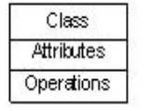

*Interface***:**  Interface defines a set of operations which specify the responsibility of a class



*Use case***:** Use case represents a set of actions performed by a system for a specific goal.

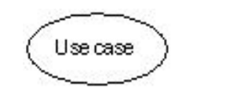

*Component:* Component describes physical part of a system.

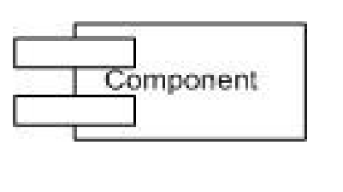

*Node***:** A node can be defined as a physical element that exists at run time.

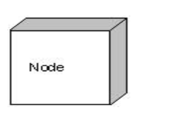

**Behavioral things:**

A behavioral thing consists of the dynamic parts of UML models. Following are the behavioral things:

***Interaction:***Interaction is defined as a behavior that consists of a group of messages exchanged among elements to accomplish a specific task.

***State machine:***State machine is useful when the state of an object in its life cycle is important. It defines the sequence of states an object goes through in response to events. Events are external factors responsible for state change.

Message

State

**Grouping things**

Grouping things can be defined as a mechanism to group elements of a UML model together. There is only one grouping thing available.

***Package****:*Package is the only one grouping thing available for gathering structural and behavioral things.



**Annotational things**: Annotational things can be defined as a mechanism to capture remarks, descriptions, and comments of UML model elements. Note is the only one Annotational thing available.

*Note:*A note is used to render comments, constraints etc of an UML element.



**Relationships In UML:** Relationship is another most important building block of UML. It shows how elements are associated with each other and this association describes the functionality of an application. There are four kinds of relationships available.

*Dependency:* Dependency is a relationship between two things in which change in one element also affects the other one.

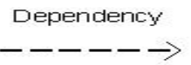

*Association:* Association is basically a set of links that connects elements of an UML model. It also describes how many objects are taking part in that relationship.

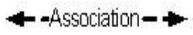

*Generalization:* Generalization can be defined as a relationship which connects a specialized element with a generalized element. It basically describes inheritance relationship in the world of objects.

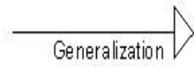

*Realization:* Realization can be defined as a relationship in which two elements are connected. One element describes some responsibility which is not implemented and the other one implements them. This relationship exists in case of interfaces.

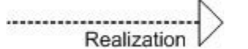

**UML Diagrams:** UML diagrams are the ultimate output of the entire discussion. All the elements, relationships are used to make a complete UML diagram and the diagram represents a system. The visual effect of the UML diagram is the most important part of the entire process. All the other elements are used to make it a complete one.

UML includes the following nine diagrams and the details are described in the following

* Class diagram
* Object diagram
* Use case diagram
* Sequence diagram
* Collaboration diagram
* Activity diagram
* State Chart diagram
* Deployment diagram
* Component diagram

**ARCHITECTURE OF UML**

Before designing a system the architecture is made with different perspectives in mind. The most important part is to visualize the system from different viewer’s perspective. The better we understand the better we make the system. UML plays an important role in defining different perspectives of a system. These perspectives are:

* Design
* Implementation
* Process
* Deployment

And the centre is the **Use Case view** which connects all these four. A Use case represents the functionality of the system. So the other perspectives are connected with use case.

**Design** of a system consists of classes, interfaces and collaboration. UML provides class diagram, object diagram to support this. Implementation defines the components assembled together to make a complete physical system. UML component diagram is used to support implementation perspective.

**Process** defines the flow of the system. So the same elements as used in Design are also used to support this perspective.

**Deployment** represents the physical nodes of the system that forms the hardware. UML deployment diagram is used to support this perspective.

1. **Automatic Teller Machine (ATM) :**

**Description of ATM System:**

The software to be designed will control a simulated automated teller machine (ATM) having a magnetic stripe reader for reading an ATM card, a customer console (keyboard and display) for interaction with the customer, a slot for depositing envelopes, a dispenser for cash , a printer for printing customer receipts, and a key-operated switch to allow an operator to start or stop the machine. The ATM will communicate with the bank's computer over an appropriate communication link. (The software on the latter is not part of the requirements for this problem.)

The ATM will service one customer at a time. A customer will be required to insert an ATM card and enter a personal identification number (PIN) - both of which will be sent to the bank for validation as part of each transaction. The customer will then be able to perform one or more transactions. The card will be retained in the machine until the customer indicates that he/she desires no further transactions, at which point it will be returned - except as noted below.

The ATM must be able to provide the following services to the customer:

1. A customer must be able to make a cash withdrawal from any suitable account linked to the card. Approval must be obtained from the bank before cash is dispensed.
2. A customer must be able to make a deposit to any account linked to the card, consisting of cash and/or checks in an envelope. The customer will enter the amount of the deposit into the ATM, subject to manual verification when the envelope is removed from the machine by an operator. Approval must be obtained from the bank before physically accepting the envelope.
3. A customer must be able to make a transfer of money between any two accounts linked to the card.
4. A customer must be able to make a balance inquiry of any account linked to the card.
5. A customer must be able to abort a transaction in progress by pressing the Cancel key instead of responding to a request from the machine.

The ATM will communicate each transaction to the bank and obtain verification that it was allowed by the bank. Ordinarily, a transaction will be considered complete by the bank once it has been approved. In the case of a deposit, a second message will be sent to the bank indicating that the customer has deposited the envelope. (If the customer fails to deposit the envelope within the timeout period, or presses cancel instead, no second message will be sent to the bank and the deposit will not be credited to the customer.)

If the bank determines that the customer's PIN is invalid, the customer will be required to re-enter the PIN before a transaction can proceed. If the customer is unable to successfully enter the PIN after three tries, the card will be permanently retained by the machine, and the customer will have to contact the bank to get it back.

If a transaction fails for any reason other than an invalid PIN, the ATM will display an explanation of the problem, and will then ask the customer whether he/she wants to do another transaction.

The ATM will provide the customer with a printed receipt for each successful transaction, showing the date, time, machine location, type of transaction, account(s), amount, and ending and available balance(s) of the affected account ("to" account for transfers).

The ATM will have a key-operated switch that will allow an operator to start and stop the servicing of customers. After turning the switch to the "on" position, the operator will be required to verify and enter the total cash on hand. The machine can only be turned off when it is not servicing a customer. When the switch is moved to the "off" position, the machine will shut down, so that the operator may remove deposit envelopes and reload the machine with cash, blank receipts, etc.

1. **USE CASE DIAGRAM :**

**Overview:**

To model a system the most important aspect is to capture the dynamic behaviour. Use case diagram is dynamic in nature there should be some internal or external factors for making the interaction. These internal and external agents are known as actors.

Contents: actors, use cases and their relationships.

The diagram is used to model the system/subsystem of an application. A single use case diagram captures a particular functionality of a system.

**Purpose:** The purpose of use case diagram is to capture the dynamic aspect of a system. But this definition is too generic to describe the purpose. Because other four diagrams (activity, sequence, collaboration and State chart) are also having the same purpose. So we will look into some specific purpose which will distinguish it from other four diagrams. Use case diagrams are used to gather the requirements of a system including internal and external influences. These requirements are mostly design requirements. So when a system is analyzed to gather its functionalities use cases are prepared and actors are identified.

So in brief, the purposes of use case diagrams can be as follows:

* Used to gather requirements of a system.
* Used to get an outside view of a system.
* Identify external and internal factors influencing the system.
* Show the interacting among the requirements are actors

**USE CASE DIAGRAM ATM:**



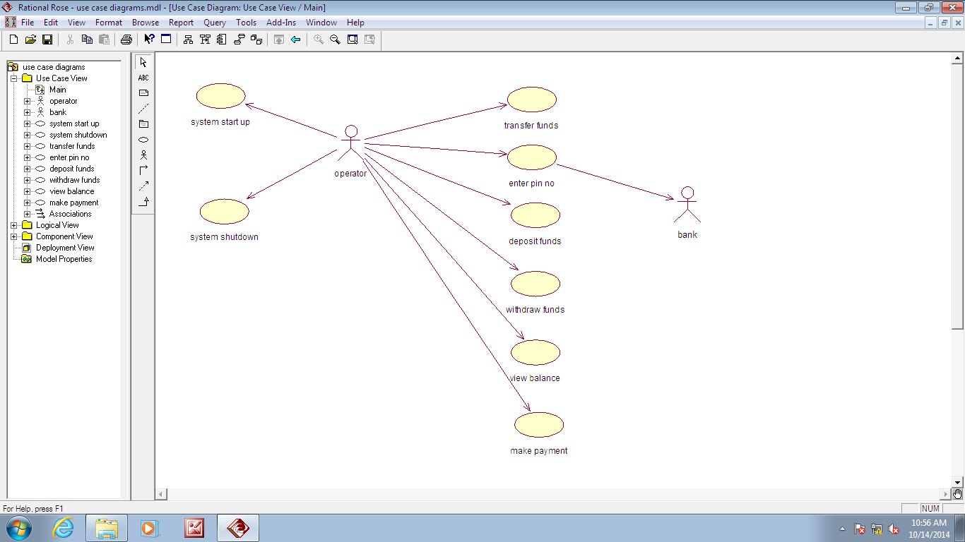

**DOCUMENTATION:**

#### Withdrawal Use Case

A withdrawal transaction asks the customer to choose a type of account to withdraw from (e.g. checking) from a menu of possible accounts, and to choose a dollar amount from a menu of possible amounts. The system verifies that it has sufficient money on hand to satisfy the request before sending the transaction to the bank. (If not, the customer is informed and asked to enter a different amount.) If the transaction is approved by the bank, the appropriate amount of cash is dispensed by the machine before it issues a receipt. A withdrawal transaction can be cancelled by the customer pressing the Cancel key any time prior to choosing the dollar amount.

#### Deposit Use Case

A deposit transaction asks the customer to choose a type of account to deposit to (e.g. checking) from a menu of possible accounts, and to type in amount on the keyboard. The transaction is initially sent to the bank to verify that the ATM can accept a deposit from this customer to this account. If the transaction is approved, the machine accepts an envelope from the customer containing cash and/or checks before it issues a receipt. Once the envelope has been received, a second message is sent to the bank, to confirm that the bank can credit the customer's account - contingent on manual verification of the deposit envelope contents by an operator later.

#### Transfer Use Case

A transfer transaction asks the customer to choose a type of account to transfer from (e.g. checking) from a menu of possible accounts, to choose a different account to transfer to, and to type in a dollar amount on the keyboard. No further action is required once the transaction is approved by the bank before printing the receipt.

A transfer transaction can be cancelled by the customer pressing the Cancel key any time prior to entering a dollar amount.

#### Inquiry Use Case

An inquiry transaction asks the customer to choose a type of account to inquire about from a menu of possible accounts. No further action is required once the transaction is approved by the bank before printing the receipt. An inquiry transaction can be cancelled by the customer pressing the Cancel key any time prior to choosing the account to inquire about.

**Validate User Use Case**

This use case is for validate the user i.e check the pin number, when the bank reports that the customer's transaction is disapproved due to an invalid PIN. The customer is required to re-enter the PIN and the original request is sent to the bank again. If the bank now approves the transaction, or disapproves it for some other reason, the original use case is continued; otherwise the process of re-entering the PIN is repeated. Once the PIN is successfully re-entered. If the customer fails three times to enter the correct PIN, the card is permanently retained, a screen is displayed informing the customer of this and suggesting he/she contact the bank, and the entire customer session is aborted.

**PrintBill Use Case**

This usecase is for printing corresponding bill after transactions (withdraw or deposit ,or balance enquiry, transfer) are completed.

**Update Account Use Case**

This usecase is for updating corresponding user accounts after transactions (withdraw or deposit or transfer) are completed.

**VIVA QUESTIONS:**

1. What is UML?

2. What is modeling? What are the advantages of creating a model?

3. What are the major three types of modeling used?

4. Mention the different kinds of modeling diagrams used?

5. What is a Use Case?

1. **CLASS DIAGRAM :**

**Class diagram for ATM:**



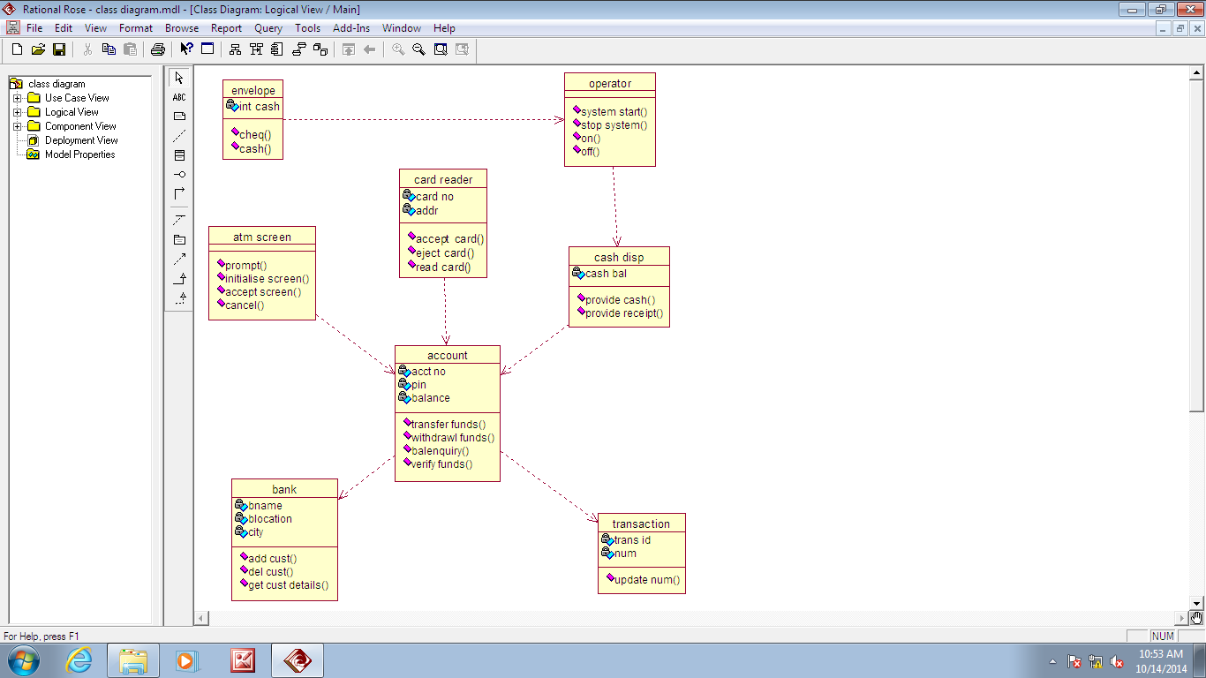**DOCUMENTATION:**

**Overview:**

The class diagram is a static diagram. It represents the static view of an application. Class diagram is not only used for visualizing, describing and documenting different aspects of a system but also for constructing executable code of the software application. The class diagram describes the attributes and operations of a class and also the constraints imposed on the system. The class diagram shows a collection of classes, interfaces, associations, collaborations and constraints. It is also known as a structural diagram.

**Purpose:**

The purpose of the class diagram is to model the static view of an application. The class diagrams are the only diagrams which can be directly mapped with object oriented languages and thus widely used at the time of construction. The UML diagrams like activity diagram, sequence diagram can only give the sequence flow of the application but class diagram is a bit different. So it is the most popular UML diagram in the coder community. So the purpose of the class diagram can be summarized as:

* Analysis and design of the static view of an application.
* Describe responsibilities of a system.
* Base for component and deployment diagrams.
* Forward and reverse engineering.

**Contents:** Class diagrams commonly contain the following things

* Classes
* Interfaces
* Collaborations

Dependency, generalization and association relationships:

**VIVA QUESTIONS:**

1. What is a class?
2. What is an attribute? Give example
3. What is a formal class or abstract class?
4. Write some applications of object model?
5. What is the need of a Class diagram?

**3. INTERACTION DIAGRAMS :**

**I. Sequence diagram for ATM:**



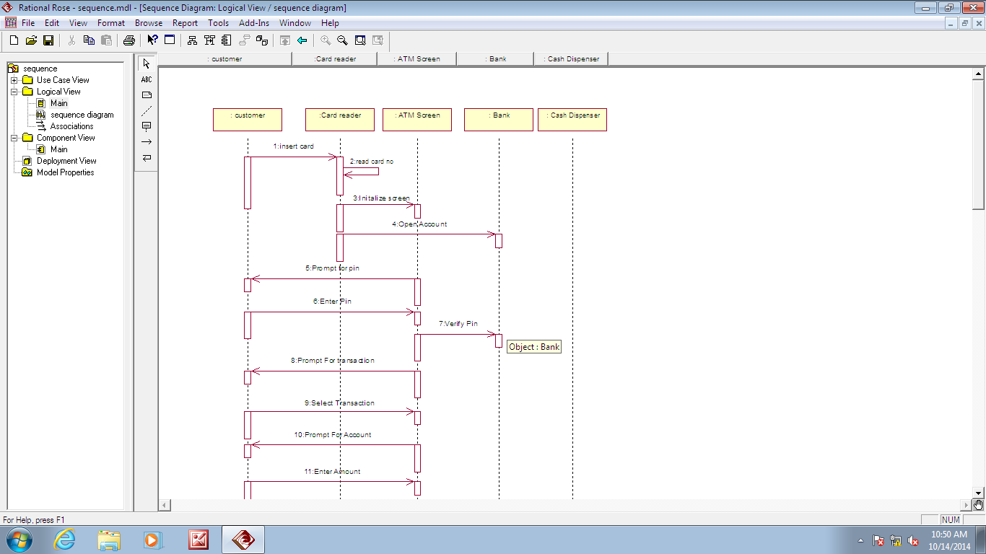

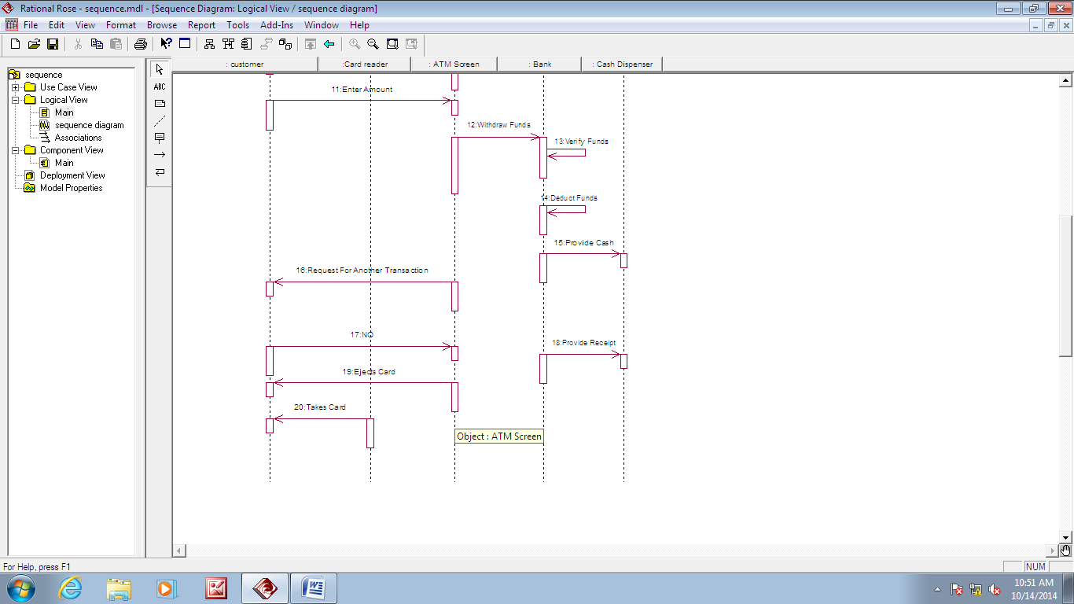**Documentation:**

We have two types of interaction diagrams in UML. One is sequence diagram and the other is a collaboration diagram. The sequence diagram captures the time sequence of message flow from one object to another and the collaboration diagram describes the organization of objects in a system taking part in the message flow.

So the following things are too identified clearly before drawing the interaction diagram:

1. Objects taking part in the interaction.
2. Message flows among the objects.
3. The sequence in which the messages are flowing.
4. Object organization.

**Purpose:**

1. To capture dynamic behavior of a system.
2. To describe the message flow in the system.
3. To describe structural organization of the objects.
4. To describe interaction among objects.

**Contents of a Sequence Diagram**

* Objects
* Focus of control
* Messages
* Life line
* Contents

**VIVA QUESTIONS:**

1. What is the need of an Interaction diagram?
2. What are the characteristic features of an Interaction diagram?
3. Write the Guidelines for identifying part of relationship.
4. What is meant by sequence diagram?
5. What is the difference between collaboration and sequence diagram?

**4. COLLABORATION DIAGRAM FOR ATM :**



**Contents of a Collaboration Diagram**

* Objects
* Links
* Messages

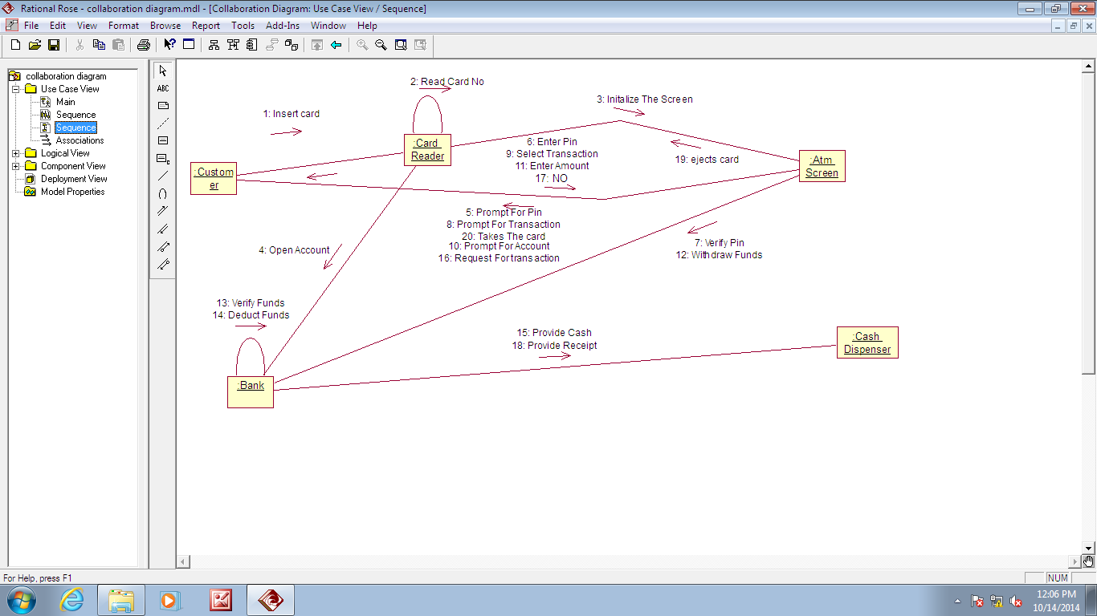

**VIVA QUESTION:**

1. What is the need of an Interaction diagram?
2. What are the characteristic features of an Interaction diagram?
3. Write the Guidelines for identifying part of relationship.
4. What is meant by sequence diagram?
5. What is the difference between collaboration and sequence diagram?
6. **STATE Chart Diagram for ATM:**



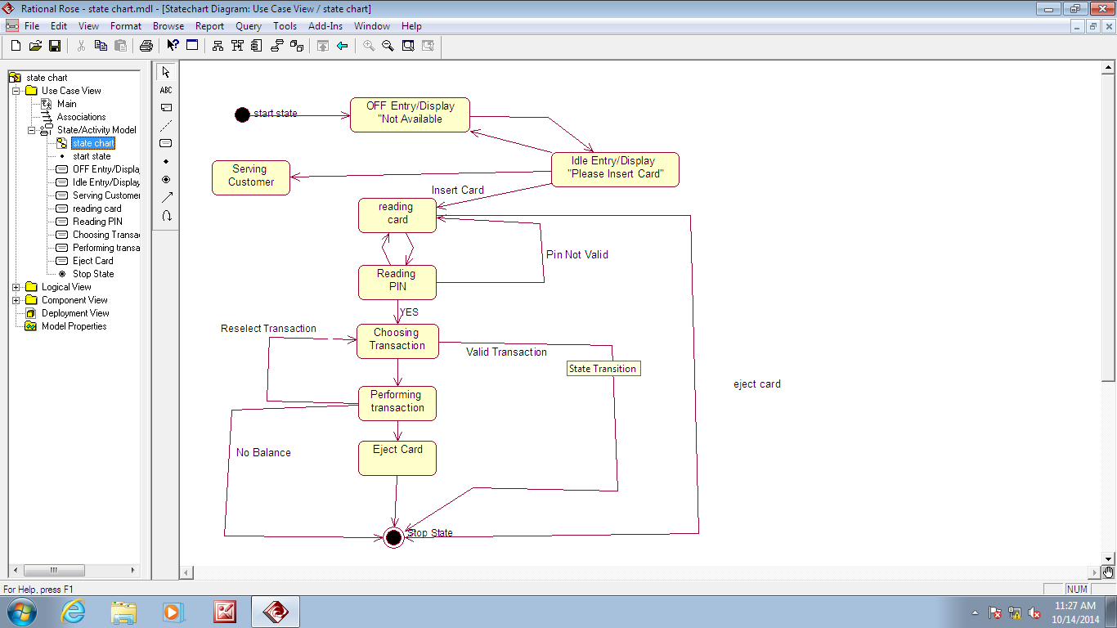

**documentation:**

State chart diagram is used to model dynamic nature of a system. They define different states of an object during its lifetime. And these states are changed by events. So State chart diagrams are useful to model reactive systems. Reactive systems can be defined as a system that responds to external or internal events.

State chart diagram describes the flow of control from one state to another state. States are defined as a condition in which an object exists and it changes when some event is triggered. So the most important purpose of State chart diagram is to model life time of an object from creation to termination.

State chart diagrams are also used for forward and reverse engineering of a system. But the main purpose is to model reactive system.

Following are the main purposes of using State chart diagrams:

1. To model dynamic aspect of a system.
2. To model life time of a reactive system.
3. To describe different states of an object during its life time.
4. Define a state machine to model states of an object.

**Contents**

Simply state and composite states

Transitions, including events and actions

**Common use**

They are use to model the dynamic aspects of a system.

Event ordered behavior of any kind of objects, to model reactive objects.

**VIVA QUESTIONS:**

1. What is an state chart?
2. What is the difference between the flowchart and state chart
3. Which type of diagram is state chart?
4. What are objects used in this diagram?
5. What is timeline?
6. **Activity Diagram :** 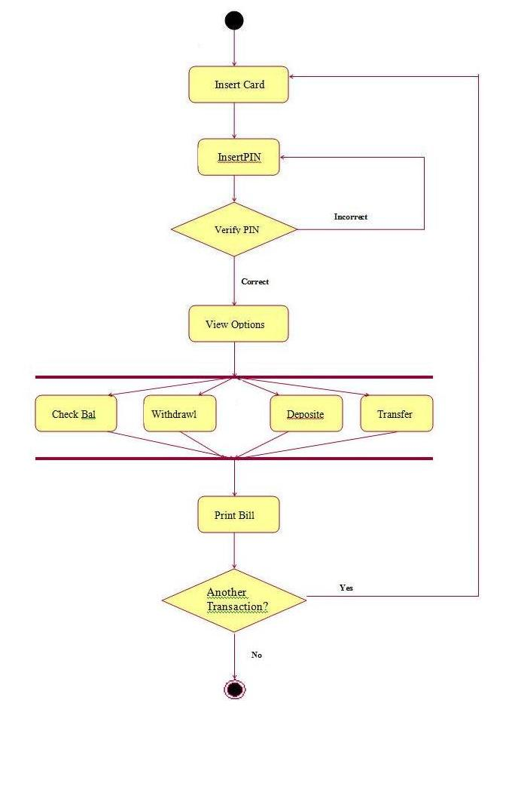

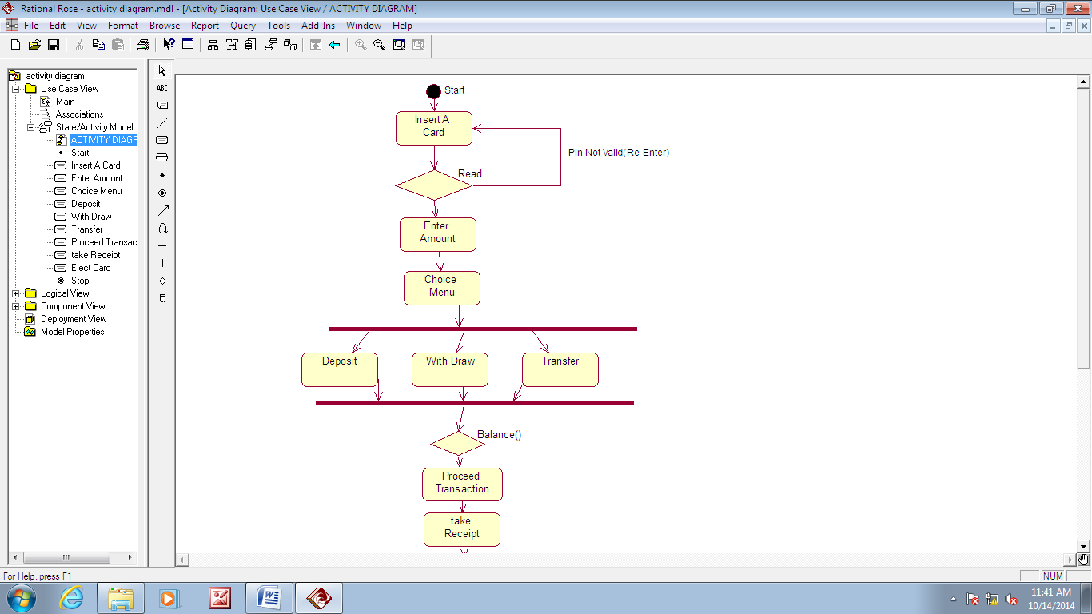

**documentation:**

Activity diagram is basically a flow chart to represent the flow form one activity to another . The activity can be described as an operation of the system. So the control flow is drawn from one operation to another. This flow can be sequential, branched or concurrent. Activity diagrams deals with all type of flow by using elements like fork, join etc.

**Contents:** Initial/Final State , Activity , Fork & Join , Branch , Swimlanes

**Fork:** A fork represents the splitting of a single flow of control into two or more concurrent Flow of control. A fork may have one incoming transition and two or more outgoing transitions, each of which represents an independent flow of control. Below fork the activities associated with each of these path continues in parallel.

**Join:** A join represents the synchronization of two or more concurrent flows of control. A join may have two or more incoming transition and one outgoing transition. Above the join the activities associated with each of these paths continues in parallel.

**Branching**

A branch specifies alternate paths takes based on some Boolean expression Branch is represented by diamond Branch may have one incoming transition and two or more outgoing one on each outgoing transition, you place a Boolean expression shouldn’t overlap but they should cover all possibilities.

**Swim lane:**

Swim lanes are useful when we model workflows of business processes to partition the activity states on an activity diagram into groups. Each group representing the business organization responsible for those activities, these groups are called Swim lanes.

**VIVA QUESTIONS:**

1. What is an activity diagram?
2. Name the models in objector?
3. Define Prototype?
4. What are the building rules of activity diagram?
5. How it is useful?

**Swimlanes diagram of Atm:**

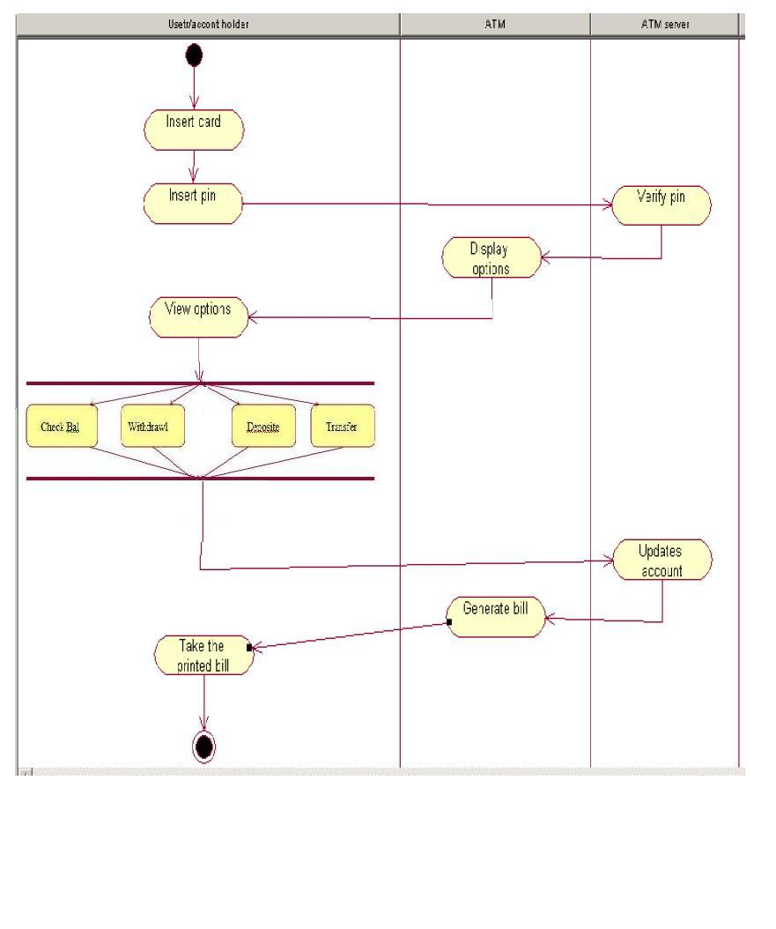

**7. Component Diagram :**



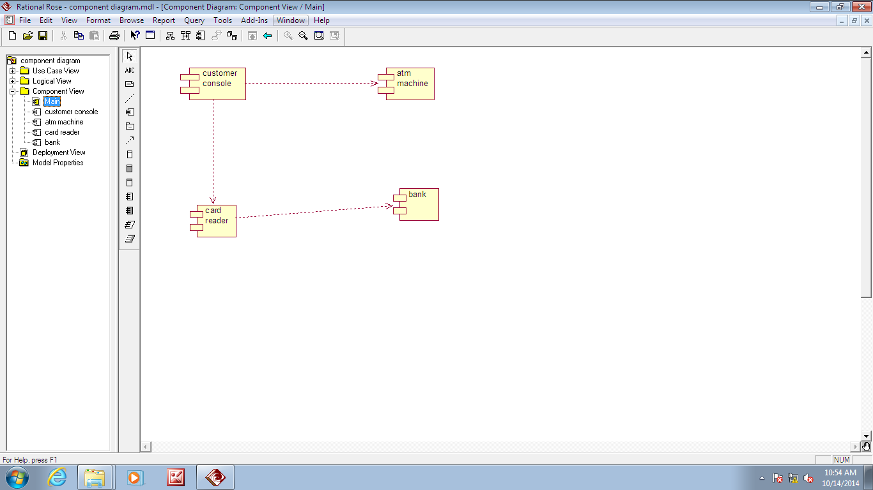

**documentation:**

Component diagrams are used to model physical aspects of a system. Now the question is what are these physical aspects? Physical aspects are the elements like executables, libraries, files, documents etc which resides in a node. So component diagrams are used to visualize the organization and relationships among components in a system. These diagrams are also used to make executable systems.

**Purpose:** Component diagrams can be described as a static implementation view of a system. Static implementation represents the organization of the components at a particular moment.

A single component diagram cannot represent the entire system but a collection of

Diagrams are used to represent the whole.

Before drawing a component diagram the following artifacts are to be identified clearly:

* Files used in the system.
* Libraries and other artifacts relevant to the application.
* Relationships among the artifacts.
* Now after identifying the artifacts the following points needs to be followed:
* Use a meaningful name to identify the component for which the diagram is to be drawn.
* Prepare a mental layout before producing using tools.
* Use notes for clarifying important points.

Now the usage of component diagrams can be described as:

* 1. Model the components of a system.
  2. Model database schema.
  3. Model executables of an application.
  4. Model system's source code.

**Contents :** Components , Interfaces , Relationships

**VIVA QUESTIONS:**

1. What is meant by component?
2. What is meant by node?
3. How it is useful for designing of project?
4. What is the relation between the nodes used in the component diagram?
5. Write the building rules of component diagram?
6. **DEPLOYMENT DIAGRAM :** 

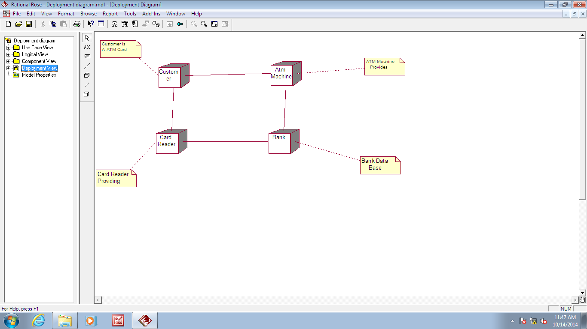

**documentation:**

Deployment diagrams are used to visualize the topology of the physical components of a system where the software components are deployed. So deployment diagrams are used to describe the static deployment view of a system. Deployment diagrams consist of nodes and their relationships.

**Purpose:** The name Deployment itself describes the purpose of the diagram. Deployment diagrams are used describing the hardware components where software components are deployed. Component diagrams and deployment diagrams are closely related. Component diagrams are used to describe the components and deployment diagrams shows how they are deployed in hardware.

**Contents:** Nodes , Dependency & Association relationships

**VIVA QUESTIONS:**

1. What is the use of deployment diagram?
2. What is meant by interface?
3. What are the relationships used in deployment and why?
4. What is the difference between the node and package?
5. What is the difference between deployment and component diagram?
6. **Additional Experiments**

**Case Study 1**

**PROBLEM SPECIFICATION:**

Case Study of :: **LIBRARY MANAGEMENT SYSTEM.**

This Library Management System is used accomplish the tasks like ‘issue ‘, ‘return’, ‘renewal’ the book to the library. To computerize the library system, it should validate the students, staff, etc...By entering the student_id, and staff_id they used to log into the system.

The library has several volumes of books, journals, magazines, news papers so, this system should maintain the library database and also it should maintain the student, staff database for validating them.

To full fill these requirements we can to design this system by making use of the UML diagrams for better understanding the specifications.

**USE CASE DIAGRAMS OF LIBRARY MANAGEMENT SYSTEM:**

System

**Ask for a book**

**Check for availability of book**

**issue the book**

**Librarian**

**Add new books**

**collecting fines**

**Update validity**

**Student**

**Access books**

**reads magazines, journals, news papers**

<<extend>>

**renewals the book**

**returns the book**

**check for authorization**

<<include>>

<<include>>

<<include>>

<<include>>

**ACTORS:**

**1. STUDENT:** The student is the primary actor who requires the books from library.

**2. LIBRARIAN:** The Librarian is also a primary actor who acts as a mediator between the system and the student. The actions like issue, return and renewal are performed by library. He interacts with the system directly.

**USE CASES SPECIFICATION OF THE SYSTEM:**

The main tasks are performed by the system whenever student or staff is valid.

**I) MAIN FLOW OF EVENTS:**

* The student must be valid a person and have a student_id. Similarly staff must be valid a person and have a staff_id.

**II) EXCEPTION FLOW OF EVENTS:**

* The student accessing the book like magazines, journals, news papers etc...

**III) PRECONDITION:**

* The client must already have an account in the college.

**IV) POSTCONDITION:**

* The account database of client is modified after performing any action.

**CLASS DIAGRAMS OF LIBRARY MANAGEMENT SYSTEM:**

**Library**

+issue_date

+ret_date

-fine

+std_no_of_books

+stf_no_of_books

+verifies()

+issues()

+renwals()

+returns()

+dispaly fine()

**College**

+coll_name

-coll_code

+coll_address

+coll_phone

+coll_strn

+coll_data

+st_data()

+staff_data()

+coll_facalities()

+con_exam()

+con_online()

+con_events()

+con_sport()

+Operation8()

**Student**

+std_name

+std_num

+std_acc

+std_dep

+attends()

+wrt_exam()

+logsin()

+uses_facilities()

+participates()

+request book()

**Staff**

+Stf_name

+stf_num

+stf_dep

+stf_acc

+teaches()

+uses_facilities()

+conducts()

+invigilates()

+logsin()

**BooksData**

+book_name

+author_name

+book_num

+publishers

-ISBN_num

+updates()

+no_of_books()

+softcopy()

+mastercd()

depends on college data

depends on student data

Librarian

+lib_name

+lib_id

-collects_fine()

+verifies_login()

+updates()

+maintanence()

-access_lib_data()

+creates_acc()

+deletes_acc()

+checks for availability

+maintained by librarian

1..*

1

Class Diagram shows the implementation view of the system, The first section tells the Name of the class, second section shows the attributes of the class and the third section shows the operations of the class. There may be any number of students but only one library will be present and providers not more than 3-book. Here Librarian has composite aggregation with student and staff as librarian is the one who can access the data n the library auto machine . Library and librarian has simple association relationship as both have the same priority and some dependence relationships between the classes as shown.

**SEQUENCE DIAGRAM OF LIBRARY MANAGEMENT SYSTEM:**

S : student1

L : librarian

d : database

Li : library

1 : logsin()

2 : checks for authorization()

3 : creates object()

<<create>>

4 : ask for book()

5 : verifies()

6 : checks for availability()

7 : justifies

8 : display fine()

9 : asks for fine()

10 : pays

11 : updates()

12 : issue the book()

13 : updates()

14 : logsout()

15 : releases()

<<destroy>>

16 : switches off()

<<destroy>>

17 : logsoff out the library()

<<destroy>>

In sequence diagram we considered the process of issue of a book.In this the objects are the library, student, librarian and the database. When a student login into the library the librarian checks for authorization and creates an object for him. When student asks for the issue of the book the librarian, he verifies in the library in turn it checks in the database whether the student has the account

**ACTIVITY DIAGRAM OF LIBRARY MANAGEMENT SYSTEM:**



The activity here considered is the verification of the student and issuing or the returning of the book with or without fine.

The student asks for a book.

The library checks for the availability of the book. If the book

Is available it issues by verification .If the details are valid and has no fine the book is issued.

The student collects the book.

**STATE CHART DIAGRAMS OF LIBRARY MANAGEMENT SYSTEM:**



**COMPONENT DIAGRAM OF LIBRARY MANAGEMENT SYSTEM:**



**DEPLOYMENT DIAGRAM OF LIBRARY MANAGEMENT SYSTEM:**



**Case Study 2**

**Problem statement: : Reservation counter.**

**Identification of actors:**

The actors in the system are the passenger, the counter clerk and the reservation system consisting of form processing, reservation, canceling issued ticket, ticket printing and updating etc.

**Use cases:**

|  |  |  |
| --- | --- | --- |
| User | Role | Use case |
| Passenger | 1.Enquiry  2.Reservation and ticketing  3.Cancellation | 1. Enquire ticket availability and other details.  2. Reserve seats and berths etc.  3.Cancel tickets |
| Counter clerk | 1.Form data entry  2.Ticket processing  3.Updation | 1.Enter the details into system  2.Trigger ticket for printing  3.Update data in the system |
| Reservation system | Server | 1. Process reservation data, process ticketing and process cancellation.  2.Update. |

**Use case diagrams**



Passenger enquiries for the availability of Seats

**Passenger**

**Counter Clerk**

**Fill requisition form**

**Enter data into system**

**Print ticket**

**Collect fare amount & Issues ticket**

Reservation and ticketing



Cancellation of issued ticket

**Class diagram**



Class diagram for railway reservation system

**Interaction diagrams**

**Sequence diagram**



**Collaboration diagram**



Collaboration diagram for reservation

**Activity diagrams**



**Activity diagram for Enquiry of seats available**



Activity diagram for reservation process

**Component diagram**



Component diagram for reservation and ticketing

**Deployment diagram**



Deployment diagram for Railway reservation system

**Experiment II:**

**Aim: Study of Any Testing Tool (Win Runner)**

Win Runner is a program that is responsible for the automated testing of software. Win Runner is a Mercury Interactive enterprise functional testing tool for Microsoft windows applications. **Importance of Automated Testing:**

1. Reduced testing time

2. Consistent test procedures – ensure process repeatability and resource independence. Eliminates errors of manual testing

3. Reduces QA cost – Upfront cost of automated testing is easily recovered over the lifetime of the product

4. Improved testing productivity – test suites can be run earlier and more often

5. Proof of adequate testing

6. for doing tedious work – test team members can focus on quality areas.

**Win Runner Uses:**

1. With Win Runner sophisticated automated tests can be created and run on an application.

2. A series of wizards will be provided to the user, and these wizards can create tests in an automated manner.

3. Another impressive aspect of Win Runner is the ability to record various interactions, and transform them into scripts. Win Runner is designed for testing graphical user interfaces.

4. When the user make an interaction with the GUI, this interaction can be recorded. Recording the interactions allows to determine various bugs that need to be fixed.

5. When the test is completed, Win Runner will provide with detailed information regarding the results. It will show the errors that were found, and it will also give important information about them. The good news about these tests is that they can be reused many times.

6. Win Runner will test the computer program in a way that is very similar to normal user interactions. This is important, because it ensures a high level of accuracy and realism. Even if an engineer is not physically present, the Recover manager will troubleshoot any problems that may occur, and this will allow the tests to be completed without errors.

7. The Recover Manager is a powerful tool that can assist users with various scenarios. This is important, especially when important data needs to be recovered.

The goal of Win Runner is to make sure business processes are properly carried out. Win Runner uses TSL, or Test Script Language.

**Win Runner Testing Modes**

***Context Sensitive***

Context Sensitive mode records your actions on the application being tested in terms of the GUI objects you select (such as windows, lists, and buttons), while ignoring the physical location of the object on the screen. Every time you perform an operation on the application being tested, a TSL statement describing the object selected and the action performed is generated in the test script. As you record, Win Runner writes a unique description of each selected object to a GUI map.

The GUI map consists of files maintained separately from your test scripts. If the user interfaces of your application changes, you have to update only the GUI map, instead of hundreds of tests. This allows you to easily reuse your Context Sensitive test scripts on future versions of your application.

To run a test, you simply play back the test script. Win Runner emulates a user by moving the mouse pointer over your application, selecting objects, and entering keyboard input. Win Runner reads the object descriptions in the GUI map and then searches in the application being tested for objects matching these descriptions. It can locate objects in a window even if their placement has changed.

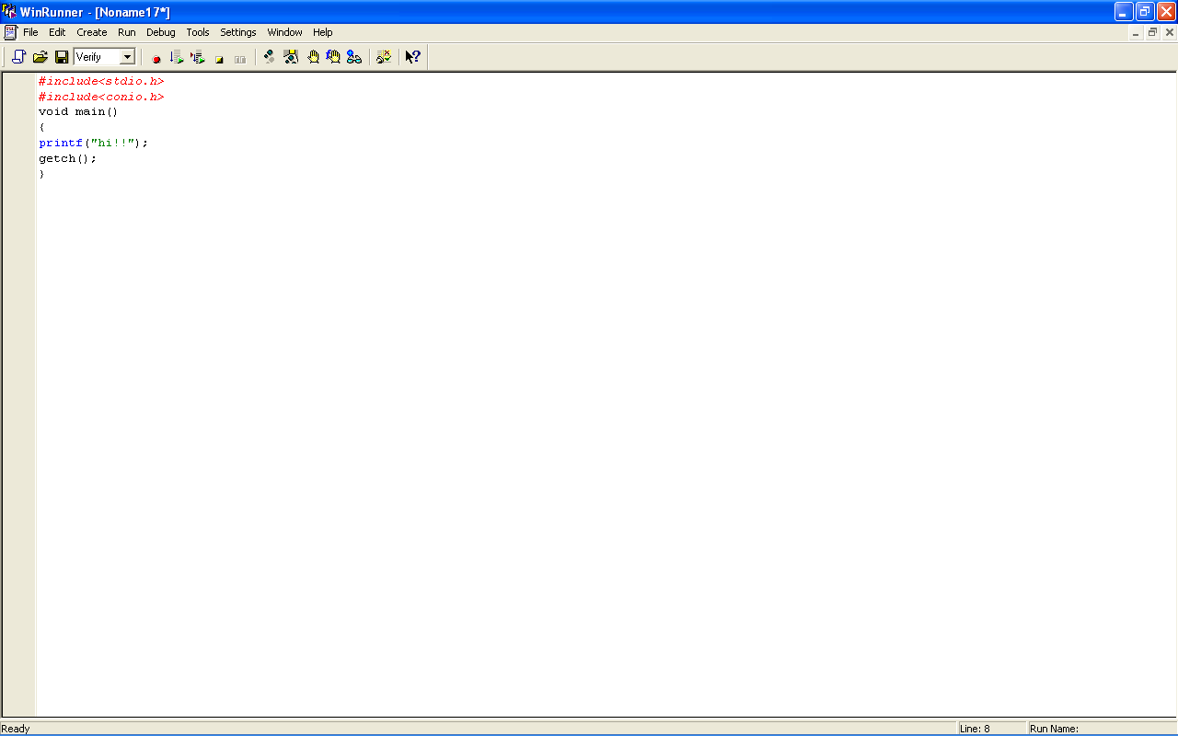

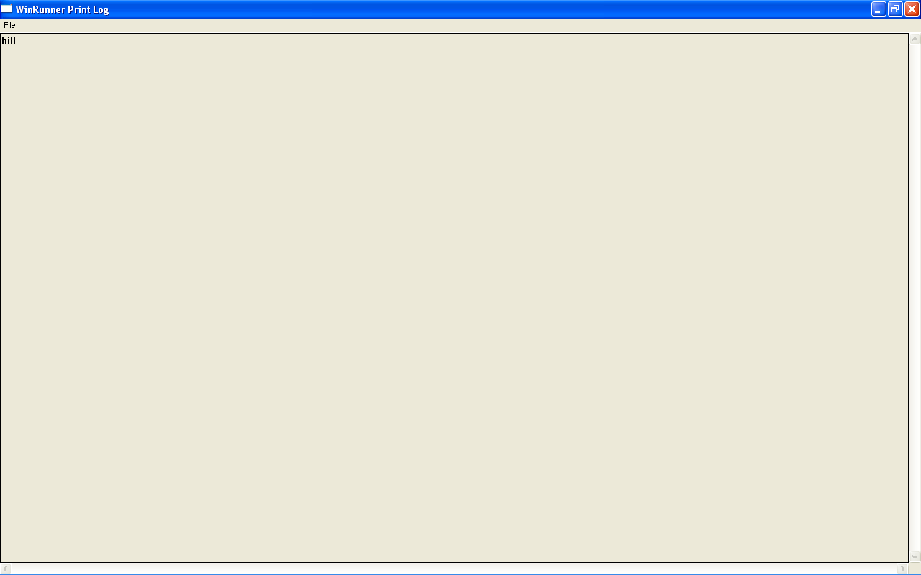

*Analog*

Analog mode records mouse clicks, keyboard input, and the exact x- and y-coordinates traveled by the mouse. When the test is run, Win Runner retraces the mouse tracks. Use Analog mode when exact mouse coordinates are important to your test, such as when testing a drawing application

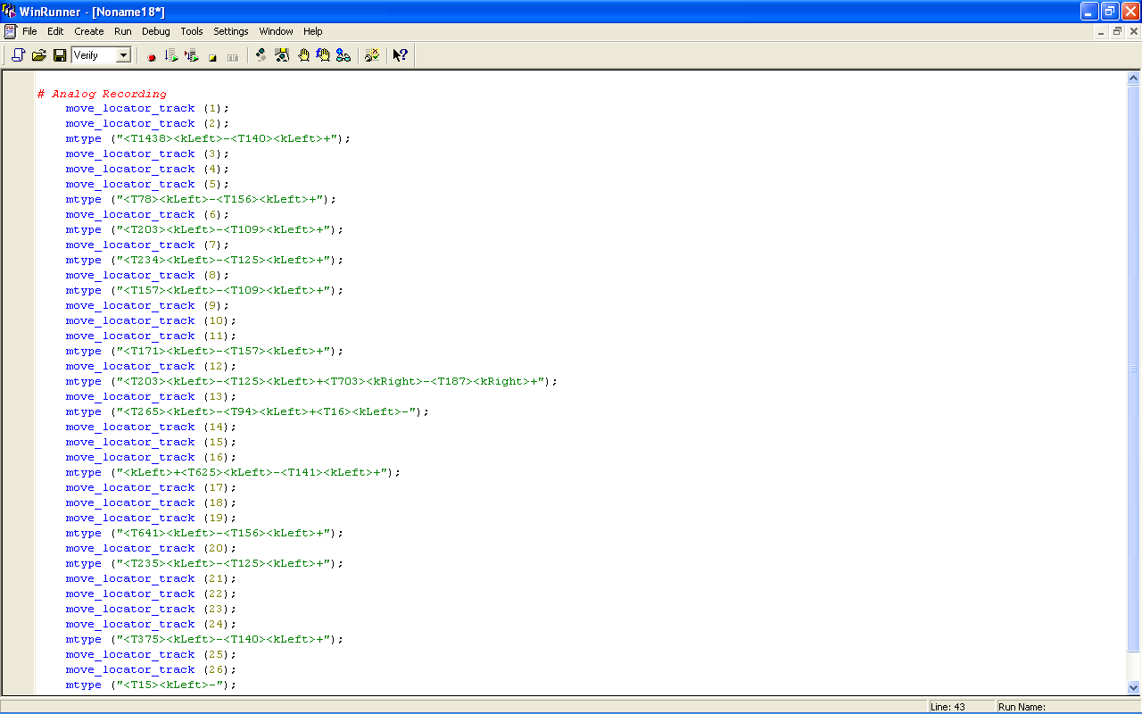

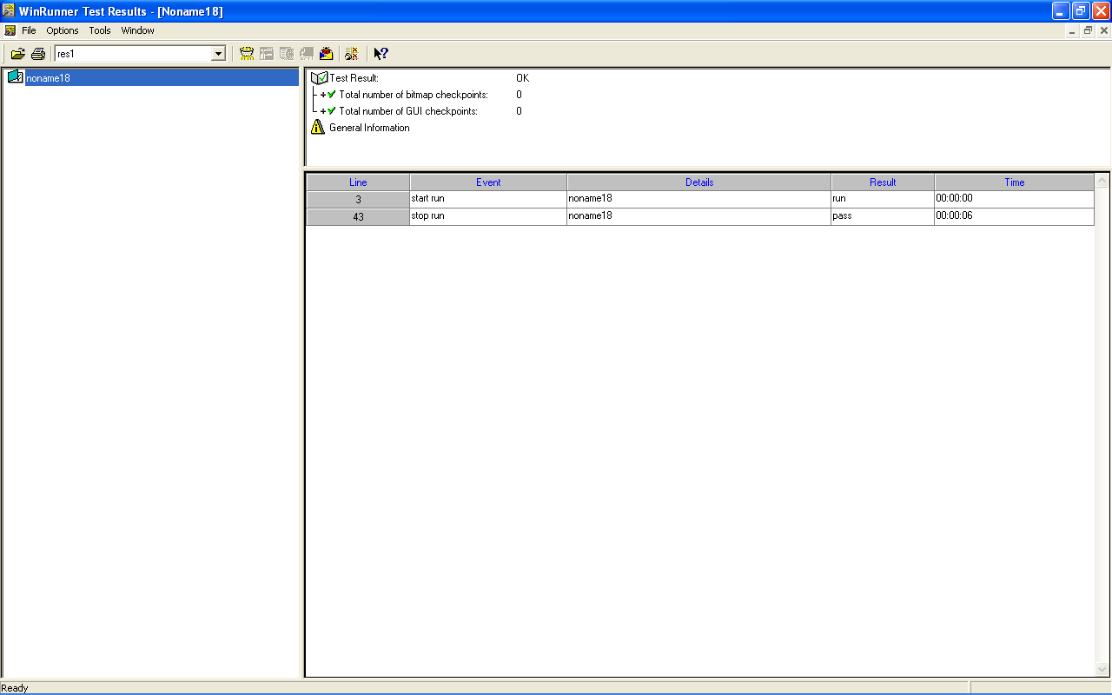

**The Win Runner Testing Process**

Testing with *Win Runner* involves six main stages:

1. **Create the GUI Map**

The first stage is to create the GUI map so Win Runner can recognize the GUI objects in the application being tested. Use the Rapid test Script wizard to review the user interface of your application and systematically add descriptions of every GUI object to the GUI map. Alternatively, you can add descriptions of individual objects to the GUI map by clicking objects while recording a test.

1. **Create Tests**

Next is creation of test scripts by recording, programming, or a combination of both. While recording tests, insert checkpoints where we want to check the response of the application being tested. We can insert checkpoints that check GUI objects, bitmaps, and databases. During this process, Win Runner captures data and saves it as *expected results*—the expected response of the application being tested.

1. **Debug Tests**

Run tests in Debug mode to make sure they run smoothly. One can set breakpoints, monitor variables, and control how tests are run to identify and isolate defects. Test results are saved in the debug folder, which can be discarded once debugging is finished. When Win Runner runs a test, it checks each script line for basic syntax errors, like incorrect syntax or missing elements in **If**, **While**, **Switch**, and **For** statements. We can use the **Syntax Check** options (**Tools >Syntax Check**) to check for these types of syntax errors before running your test.

1. **Run Tests**

Tests can be run in Verify mode to test the application. Each time Win Runner encounters a checkpoint in the test script, it compares the current data of the application being tested to the expected data captured earlier. If any mismatches are found, Win Runner captures them as *actual results*.

1. **View Results**

Following each test run, Win Runner displays the results in a report. The report details all the major events that occurred during the run, such as checkpoints, error messages, system messages, or user messages. If mismatches are detected at checkpoints during the test run, we can view the expected results and the actual results from the Test Results window. In cases of bitmap mismatches, one can also view a bitmap that displays only the difference between the expected and actual results.

We can view results in the standard Win Runner report view or in the Unified report view. The Win Runner report view displays the test results in a Windows-style viewer. The Unified report view displays the results in an HTML-style viewer (identical to the style used for Quickest Professional test results).

1. **Report Defects**

If a test run fails due to a defect in the application being tested, one can report information about the defect directly from the Test Results window. This information is sent via e-mail to the quality assurance manager, who tracks the defect until it is fixed. **Using Win runner Window** Before you begin creating tests, you should familiarize yourself with the Win Runner main window.

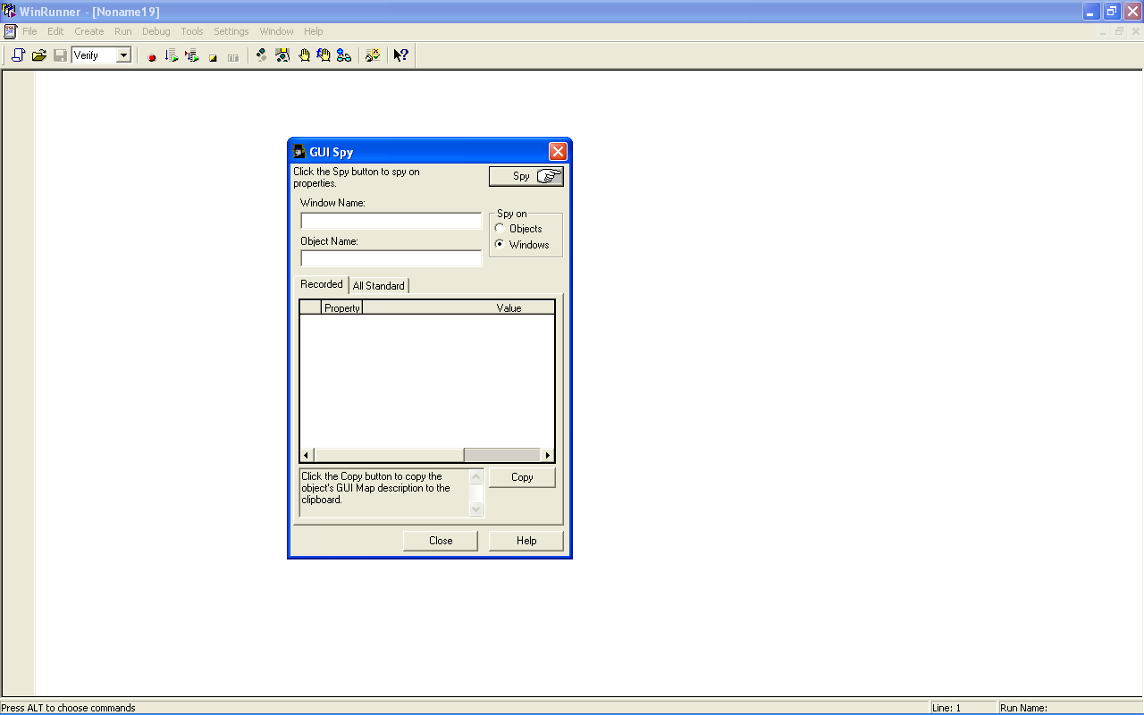

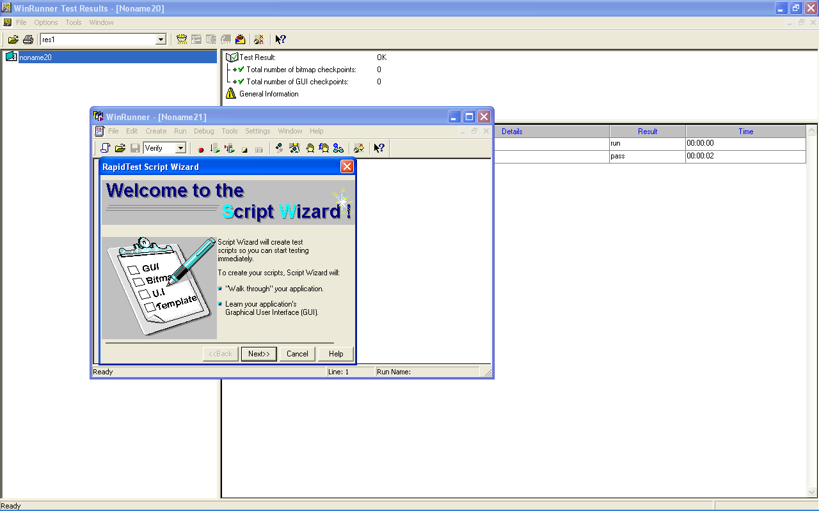

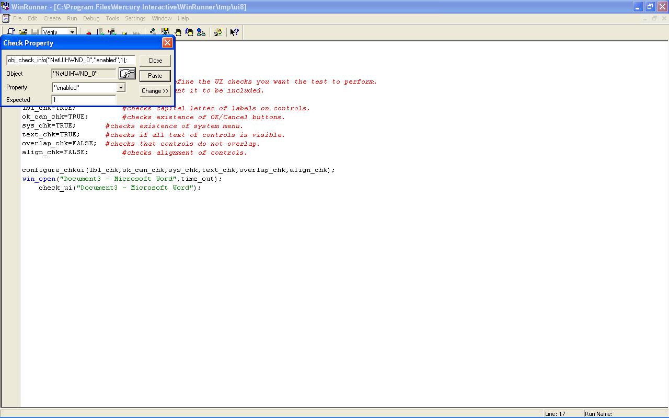

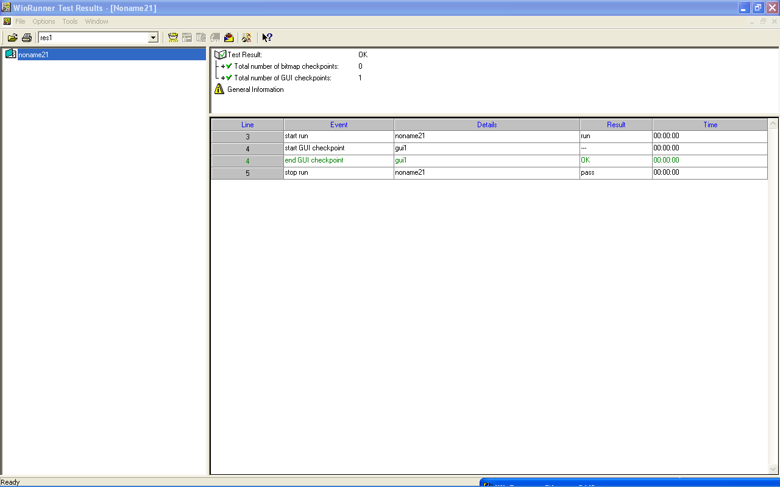

* + 1. **To start Win Runner:**

Choose **Programs** > **Win Runner** > **Win Runner** on the **Start** menu.

The first time you start Win Runner, the Welcome to Win Runner window and the ―What‘s New in Win Runner‖ help open. From the Welcome window you can create a new test, open an existing test, or view an overview of Win Runner in your default browser.

If you do not want this window to appear the next time you start Win Runner, clear the **Show on Startup** check box. To show the **Welcome to Win Runner** window upon startup from within Win Runner, choose **Settings > General Options**, click the **Environment** tab, and select the **Show Welcome screen** check box.

* + 1. **The Main Win Runner Window**

The main Win Runner window contains the following key elements:

*Win Runner title bar*

*Menu bar,* with drop-down menus of Win Runner commands

*Standard toolbar,* with buttons of commands commonly used when running a test

*User toolbar,* with commands commonly used while creating a test

*Status bar*, with information on the current command, the line number of the insertion point and the name of the current results folder

The *Standard toolbar* provides easy access to frequently performed tasks, such as opening, executing, and saving tests, and viewing test results.

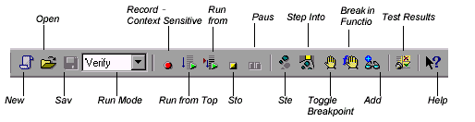

**Standard Toolbar**

The *User toolbar* displays the tools you frequently use to create test scripts. By default, the User toolbar is hidden. To display the User toolbar, choose **Window** > **User Toolbar**. When you create tests, you can minimize the Win Runner window and work exclusively from the toolbar. The User toolbar is customizable. You choose to add or remove buttons using the **Settings > Customize User Toolbar** menu option. When you re-open Win Runner, the User toolbar appears as it was when you last closed it. The commands on the Standard toolbar and the User toolbar are described in detail in subsequent lessons.

Note that you can also execute many commands using *soft keys*. Soft keys are keyboard shortcuts for carrying out menu commands. You can configure the soft key combinations for your keyboard using the Soft key Configuration utility in your Win Runner program group. For more information, see the ―Win Runner at a Glance‖ chapter in your *Win Runner User’s Guide*.

Now that you are familiar with the main Win Runner window, take a few minutes to explore these window components before proceeding to the next lesson.

**The Test Window**

You create and run Win Runner tests in the test window. It contains the following key elements:

*Test window title bar*, with the name of the open test

*Test script*, with statements generated by recording and/or programming in TSL, Mercury Interactive Test Script Language

*Execution arrow,* which indicates the line of the test script being executed during a test run, or the line that will next run if you select the Run from arrow option

*Insertion point,* which indicates where you can insert or edit text

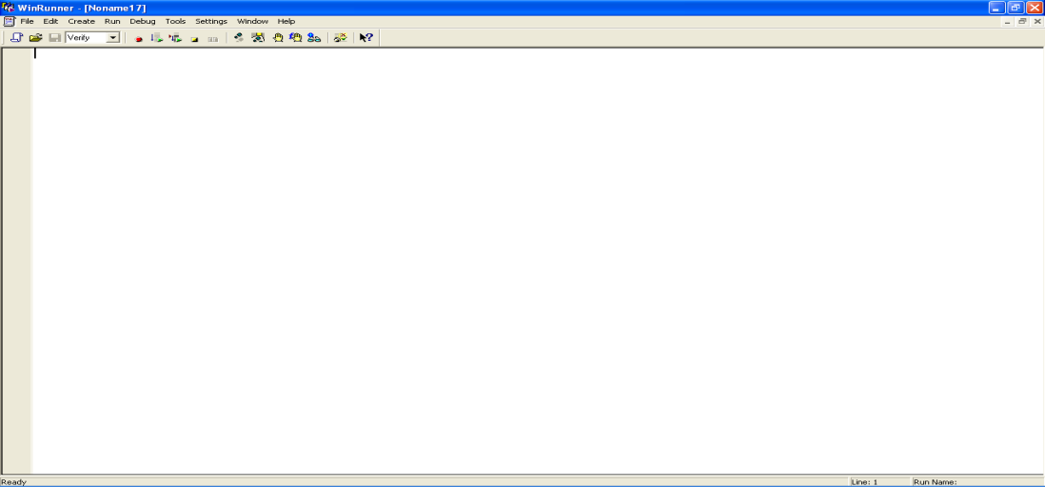



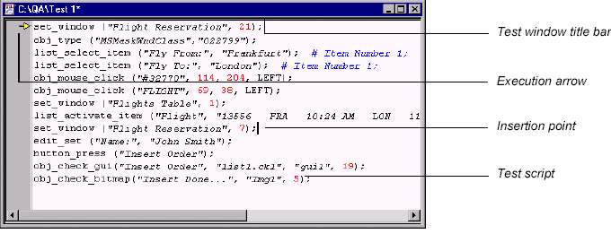

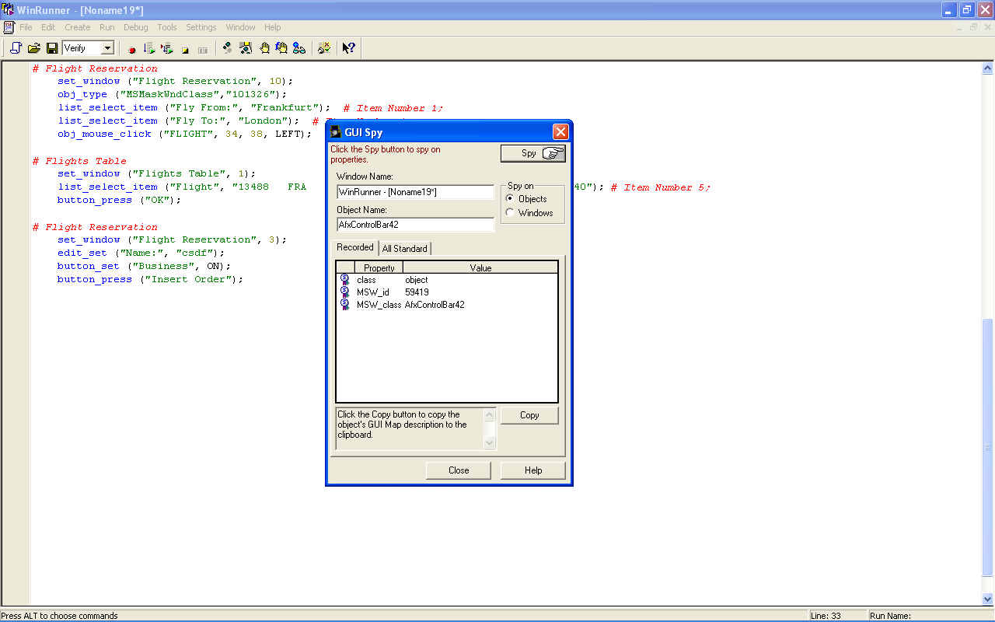

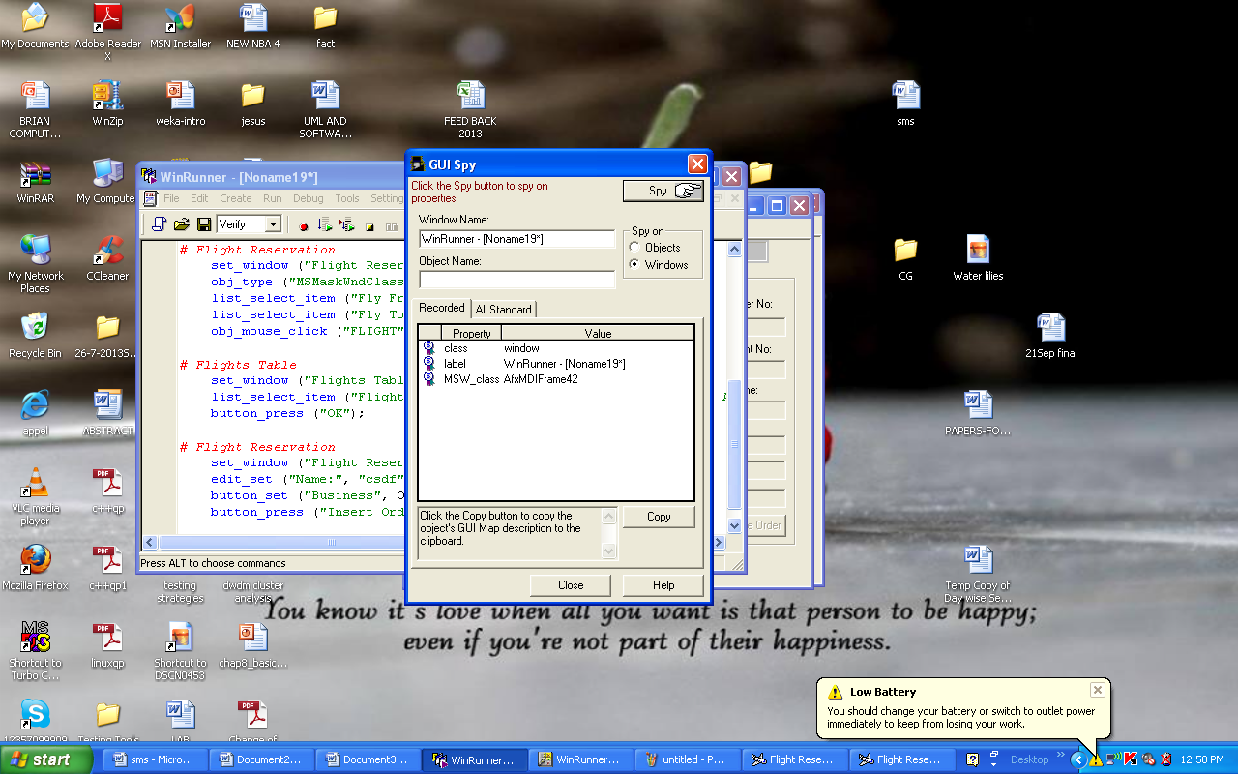

**VIVA QUESTIONS:**

1. What is an win runner?
2. Which type of tool it is?
3. What is the advantage and disadvantage of the tool?
4. For which applications is it applied?
5. How many testing techniques it contain

**Experiment III:**

**Study of any web testing tool (e.g. Selenium)**

* Selenium is a robust set of tools that supports rapid development of test automation for web-based applications. Selenium provides a rich set of testing functions specifically geared to the needs of testing of a web application. These operations are highly flexible, allowing many options for locating UI elements and comparing expected test results against actual application behavior.
* One of Selenium‘s key features is the support for executing one‘s tests on multiple browser platforms.
* **Selenium Components**
* Selenium is composed of three major tools. Each one has a specific role in aiding the development of web application test automation.
* Selenium-RC provides an API (Application Programming Interface) and library for each of its supported languages: HTML, Java, C#, Perl, PHP, Python, and Ruby. This ability to use Selenium-RC with a high-level programming language to develop test cases also allows the automated testing to be integrated with a project‘s automated build environment.

**Selenium-Grid**

* Selenium-Grid allows the Selenium-RC solution to scale for large test suites or test suites that must be run in multiple environments. With Selenium-Grid, multiple instances of Selenium-RC are running on various operating system and browser configurations; Each of these when launching register with a hub. When tests are sent to the hub they are then redirected to an available Selenium-RC, which will launch the browser and run the test. This allows for running tests in parallel, with the entire test suite theoretically taking only as long to run as the longest individual test.
* Tests developed on Firefox via Selenium-IDE can be executed on any other supported browser via a simple Selenium-RC command line.
* ** Selenium-RC server can start any executable, but depending on browser security settings there may be technical limitations that would limit certain features.

**Flexibility and Extensibility**

* Selenium is highly flexible. There are multiple ways in which one can add functionality to Selenium‘s framework to customize test automation for one‘s specific testing needs. This is, perhaps, Selenium‘s strongest characteristic when compared with proprietary test automation tools and other open source solutions. Selenium-RC support for multiple programming and scripting languages allows the test writer to build any logic they need into their automated testing and to use a preferred programming or scripting language of one‘s choice.
* Selenium-IDE allows for the addition of user-defined ―user-extensions‖ for creating additional commands customized to the user‘s needs. Also, it is possible to re-configure how the Selenium-IDE generates its Selenium-RC code. This allows users to customize the generated code to fit in with their own test frameworks. Finally, Selenium is an Open Source project where code can be modified and enhancements can be submitted for contribution.

**Test Suites**

* A test suite is a collection of tests. Often one will run all the tests in a test suite as one continuous batch-job.
* When using Selenium-IDE, test suites also can be defined using a simple HTML file. The syntax again is simple. An HTML table defines a list of tests where each row defines the file system path to each test. An example tells it all.
* <html>
* <head>
* <title>Test Suite Function Tests – Priority 1</title> </head>
* <body>
* <table>
* <tr><td><b>Suite Of Tests</b></td></tr>
* <tr><td><a href=‖./Login.html‖>Login</a></td></tr>
* <tr><td><a href=‖./SearchValues.html‖>Test Searching for Values</a></td></tr>
* <tr><td><a href=‖./SaveValues.html‖>Test Save</a></td></tr>
* </table> </body>
* </html>
* A file similar to this would allow running the tests all at once, one after another, from the Selenium-IDE.
* Test suites can also be maintained when using Selenium-RC. This is done via programming and can be done a number of ways. Commonly Junit is used to maintain a test suite if one is using Selenium-RC with Java. Additionally, if C# is the chosen language, Nunit could be employed. If using an interpreted language like Python with Selenium-RC than some simple programming would be involved in setting up a test suite. Since the whole reason for using Sel-RC is to make use of programming logic for your testing this usually isn‘t a problem.

**Few typical Selenium commands**

**Open –** opens a page using a URL.

**Click /click And Wait –** performs a click operation, and optionally waits for a new page to load.

**Verify Title/ assert Title –** verifies an expected page title.

**Verify Text Present –** verifies expected text is somewhere on the page.

**Verify Element Present –** verifies an expected UI element, as defined by its HTML tag, is present on the page.

**Verify Text –** verifies expected text and it‘s corresponding HTML tag are present on the page.

**Verify Table –** verifies a table‘s expected contents.

**Wait For Page To Load –** pauses execution until an expected new page loads. Called automatically when clickAndWait is used.

**waitForElementPresent –** pauses execution until an expected UI element, as defined by its HTML tag, is present on the page.

**Selenium IDE**

 

Test Creation

1. Create test case to log into the gallery
2. Create test case to log out of the gallery



Start Pixory 

Connect to the Server



Go to the Login Screen 

Hit the Record Button



Type in Username and Password



IDE should update

 

Hit submit Hit record again to stop

**Test Suite:**

A Test Suite inSelenium is just an HTML file that contains a table of links to tests



**Test Runner Control**



**VIVA QUESTIONS:**

1. What are components in selenium tool?
2. What is an advantage of selenium rather than winrunner?
3. Write the commands used in testing tool?
4. What is meant by test suite?
5. Is this tool is flexible or not?

**Experiment IV:**

**Aim: Study of Any Bug Tracking Tool (Bugzilla)**

Bugzilla is a ―Bug Tracking System‖ that can efficiently keep track of outstanding bugs in a product. Multiple users can access this database and query, add and manage these bugs. Bugzilla essentially comes to the rescue of a group of people working together on a product as it enables them to view current bugs and make contributions to resolve issues. Its basic repository nature works out better than the mailing list concept and an organized database is always easier to work with.

**Advantage of Using Bugzilla:**

1. Bugzilla is very adaptable to various situations. Known uses currently include IT support queues, Systems Administration deployment management, chip design and development problem tracking (both pre-and-post fabrication), and software and hardware bug tracking for luminaries such as Redhat, NASA, Linux-Mandrake, and VA Systems. Combined with systems such as CVS, Bugzilla provides a powerful, easy-to-use solution to configuration management and replication problems.
2. Bugzilla can dramatically increase the productivity and accountability of individual employees by providing a documented workflow and positive feedback for good performance. Ultimately, Bugzilla puts the power in user‘s hands to improve value to business while providing a usable framework for natural attention to detail and knowledge store to flourish.

The bugzilla utility basically allows to do the following:

* Add a bug into the database
* Review existing bug reports
* Manage the content

Bugzilla is organised in the form of bug reports that give all the information needed about a particular bug. A bug report would consist of the following fields.

* Product–>Component
* Assigned to
* Status (New, Assigned, Fixed etc)
* Summary
* Bug priority
* Bug severity (blocker, trivial etc)
* Bug reporter

**Using Bugzilla:**

Bugzilla usage involves the following activities

Setting Parameters and Default Preferences

* Creating a New User
* Impersonating a User
* Adding Products
* Adding Product Components
* Modifying Default Field Values
* Creating a New Bug
* Viewing Bug Reports

**Setting Parameters and Default Preferences:**

When we start using Bugzilla, we‘ll need to set a small number of parameters and preferences. At a minimum, we should change the following items, to suit our particular need:

Set the *maintainer*

▪ Set the *mail_delivery_method*

▪ Set *bug change policies*

▪ Set the display order of bug reports

To set parameters and default preferences:

1. Click *Parameters* at the bottom of the page.

2. Under *Required Settings*, add an email address in the *maintainer* field.

3. Click *Save Changes*.

4. In the left side *Index* list, click *Email*.

5. Select from the list of mail transports to match the transport we‘re using. If evaluating a click2try

application, select *Test*. If using SMTP, set any of the other SMTP options for your environment.

Click *Save Changes*.

6. In the left side *Index* list, click *Bug Change Policies*.

7. Select On for *commentoncreate*, which will force anyone who enters a new bug to enter a

comment, to describe the bug. Click *Save Changes*.

8. Click *Default Preferences* at the bottom of the page.

9. Select the display order from the drop-down list next to the *When viewing a bug, show comments*

*in this order* field. Click *Submit Changes*.

**Creating a New User**

Before entering bugs, make sure we add some new users. We can enter users very easily, with a minimum of information. Bugzilla uses the email address as the user ID, because users are frequently notified when a bug is entered, either because they entered the bug, because the bug is assigned to them, or because they‘ve chosen to track bugs in a certain project.

To create a new user:

1. Click **Users**.

2. Click **add** a new user.

3. Enter the **Login name**, in the form of an email address.

4. Enter the **Real name**, a password, and then click **Add**.

5. Select the **Group access options**. we‘ll probably want to enable the following options in the row titled User is a member of these groups:

* *canconfirm*
* *editbugs*
* *editcomponents*

6. Click **Update** when done with setting options.

**Impersonating a User**

**Impersonating** a user is possible, though rare, that we may need to file or manage a bug in an area that is the responsibility of another user when that user is not available. Perhaps the user is on vacation, or is temporarily assigned to another project. We can impersonate the user to create or manage bugs that belong to that user.

**Adding Products**

We‘ll add a product in Bugzilla for every product we are developing. To start with, when we first login to Bugzilla, we‘ll find a test product called **TestProduct**. We should delete this and create a new product.

To add a product:

1. At the bottom of the page, click **Products**.

2. In the **TestProduct** listing, click **Delete**.

3. Click **Yes, Delete**.

4. Now click **Add a product**.

5. Enter a product name, such as ―Widget Design Kit.‖

6. Enter a description.

1. Click **Add**. A message appears that you‘ll need to add at least one component.

**Adding Product Components**

Products are comprised of components. Software products, in particular, are typically made up of many functional components, which in turn are made up of program elements, like classes and functions. It‘s not unusual in a software development team environment for different individuals to be responsible for the bugs that are reported against a given component. Even if there are other programmers working on that component, it‘s not uncommon for one person, either a project lead or manager, to be the gatekeeper for bugs. Often, they will review the bugs as they are reported, in order to redirect them to the appropriate developer or even another team, to review the priority and severity supplied by the reporter, and sometimes to reject bugs as duplicates or enhancement requests, for example.

To add a component:

1. Click the link **add at least one component** in the message that appears after creating a new product.

2. Enter the **Component** name.

3. Enter a **Description**.

4. Enter a **default assignee**. Use one of the users we‘ve created. Remember to enter the assignee in the form of an email address.

5. Click **Add**.

6. To add more components, click the name of product in the message that reads edit other components of product <**product name**>.

**Modifying Default Field Values**

Once we begin to enter new bugs, we‘ll see a number of drop-down lists containing default values. Some of these may work just fine for our product. Others may not. We can modify the values of these fields, adding new values and deleting old ones. Let‘s take a look at the OS category.

To modify default field values:

1. At the bottom of the page, in the **Edit** section, click **Field Values**.

2. Click the link, in this case **OS**, for the field we want to edit. The OS field contains a list of operating system names. We are going to add browsers to this list. In reality, we might create a custom field instead, but for the sake of this example, just add them to the OS list.

3. Click **Add a value**. In the **Value** field, enter ―IE7.‖ Click **Add**.

4. Click **Add a value** again.

5. In the **Value** field, enter ―Firefox 3.‖

6. Click **Add**.

7. Where it reads **Add other values for the op_sys field**, click **op_sys**.

8. This redisplays the table. We should now see the two new entries at the top of the table. These values will also appear in the OS drop-down list when we create a new bug.

**Creating a New Bug**

Creating bugs is a big part of what Bugzilla does best.

To create a new bug:

1. In the top menu, click **New**.

2. If we‘ve defined more than one component, choose the component from the component list.

3. Select a **Severity** and a **Priority**. **Severity** is self-explanatory, but **Priority** is generally assumed to be the lower the number, the higher the priority. So, a **P1** is the highest priority bug, a *showstopper*.

4. Click the **OS** drop-down list to see the options, including the new browser names we entered.

5. Select one of the options.

6. Enter a summary and a description. We can add any other information of choice, but it is not required by the system, although we may determine that our bug reporting policy requires certain information.

7. Click **Commit**. Bugzilla adds our bug report to the database and displays the detail page for that bug.

**Viewing Bug Reports**

Eventually, we‘ll end up with thousands of bugs listed in the system. There are several ways to view the bugs. The easiest is to click the My Bugs link at the bottom of the page. Because we‘ve only got one bug reported, we‘ll use the standard Search function.

To find a bug:

1. Click **Reports**.

2. Click the **Search** link on the page, not the one in the top menu. This opens a page titled ―Find a Specific Bug.‖

3. Select the **Status**.

4. Select the **Product**.

5. Enter a word that might be in the title of the bug.

6. Click **Search**. If any bugs meet the criteria that we have entered, Bugzilla displays them in a list summary.

7. Click the **ID** number link to view the full bug report.

**Modifying Bug Reports**

Suppose we want to change the status of the bug. We‘ve reviewed it and have determined that it belongs to one of the users we have created earlier To modify a bug report:

1. Scroll down the full bug description and enter a comment in the **Additional Comments** field.

2. Select ―Reassign bug to‖ and replace the default user ID with one of the other user IDs you created. It must be in the format of an email address

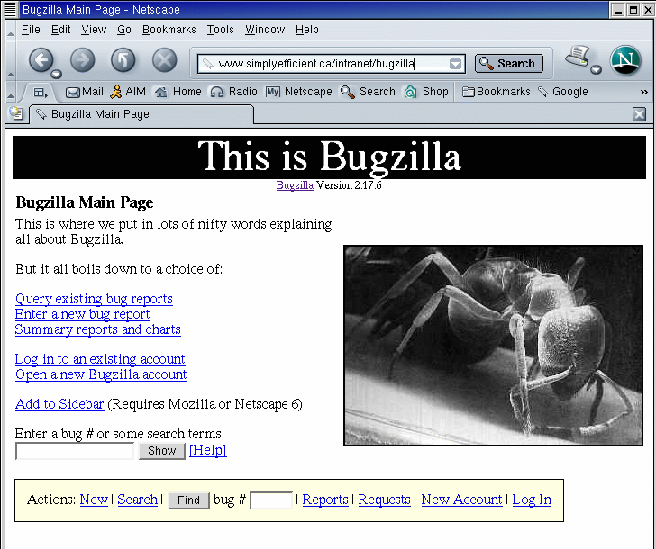

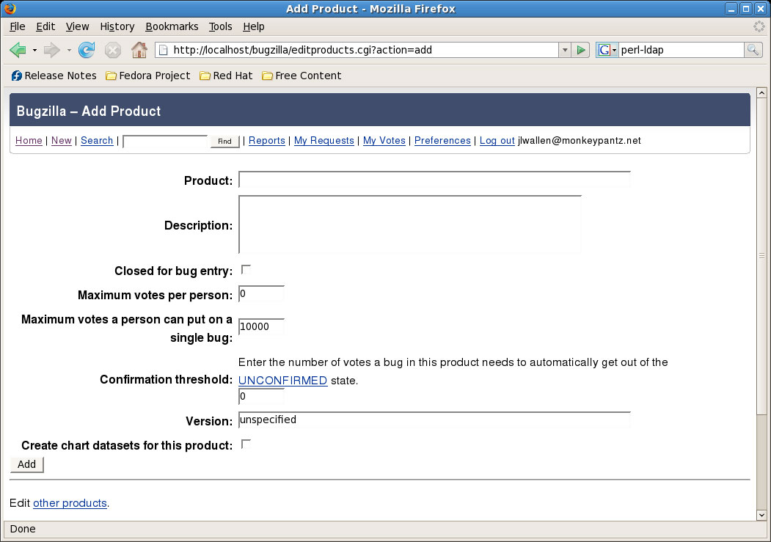

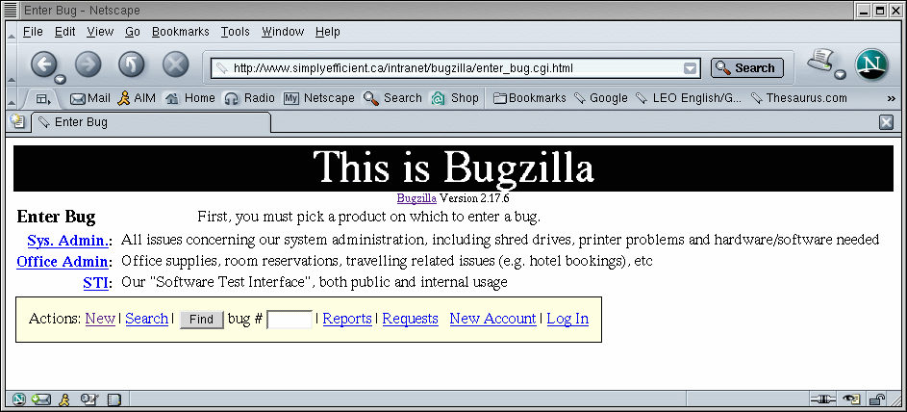

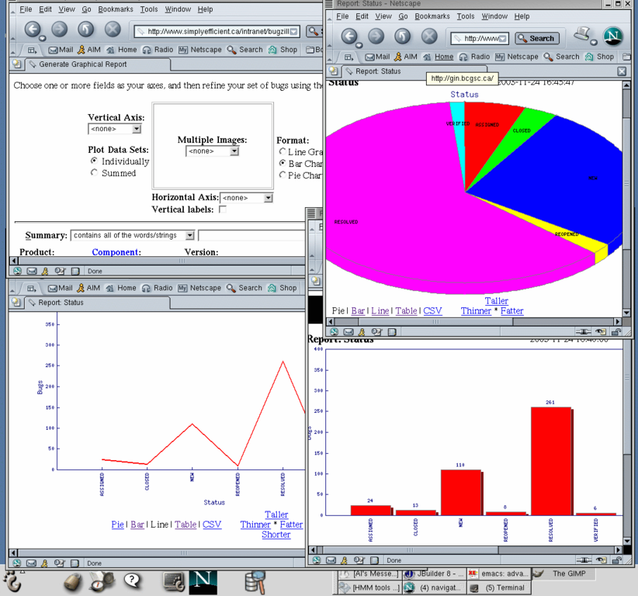

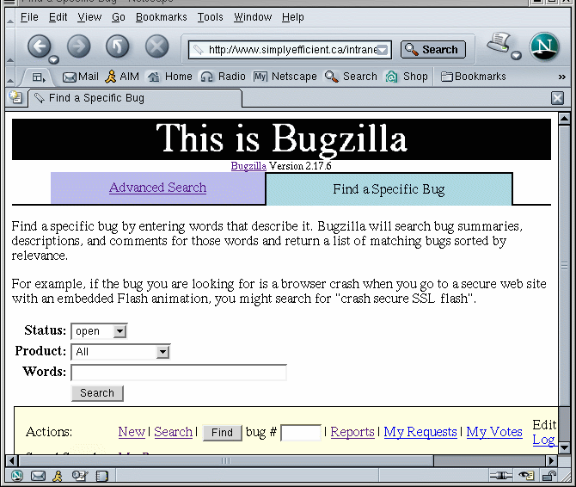

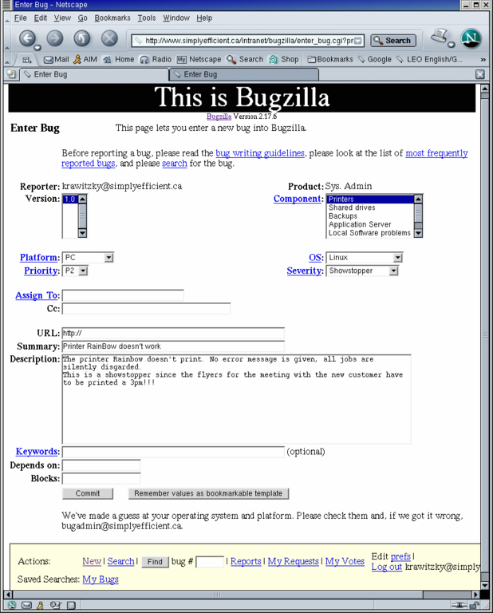

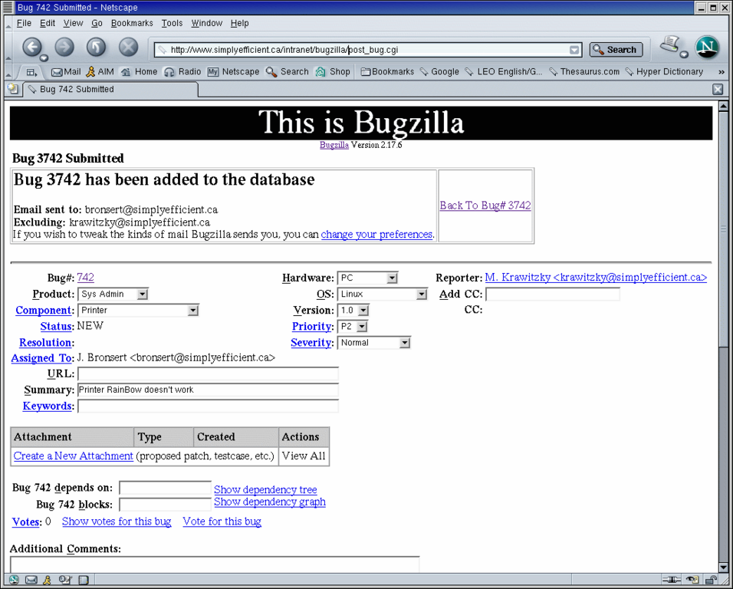

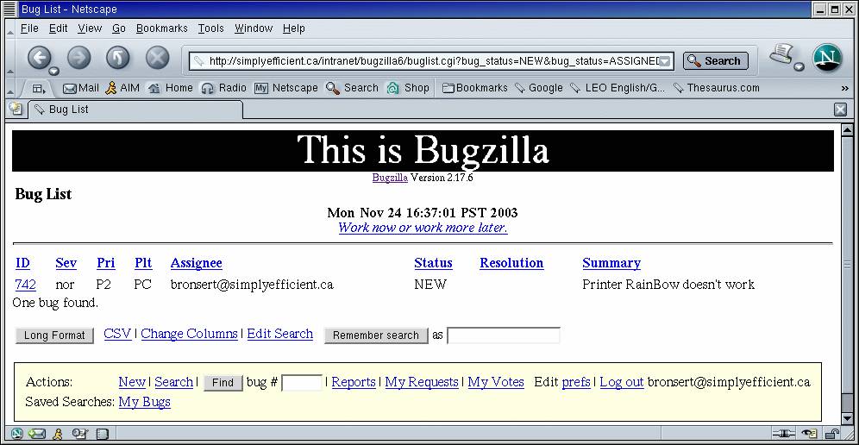



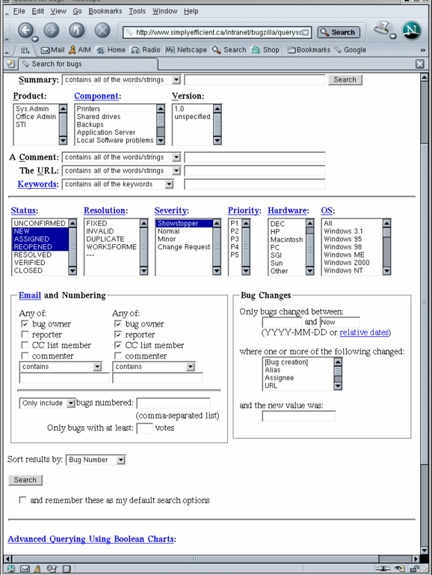

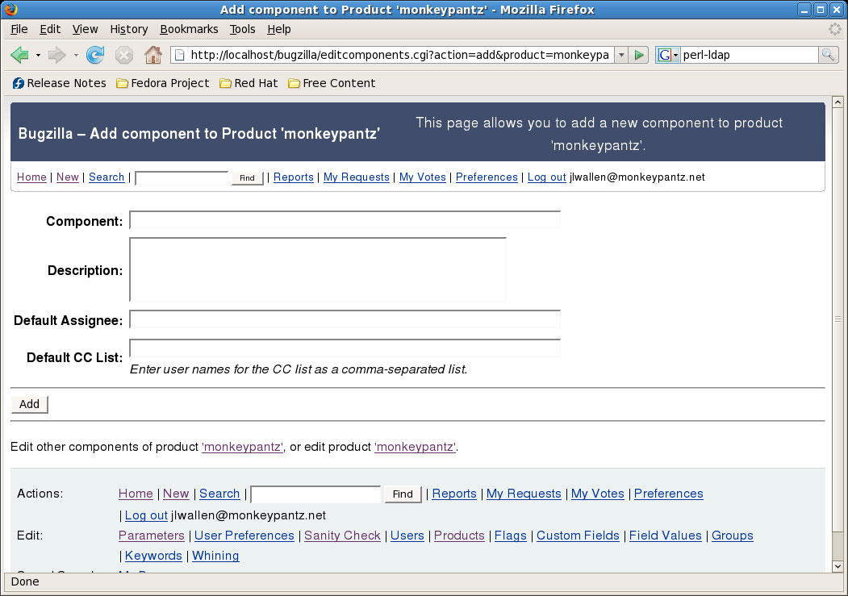

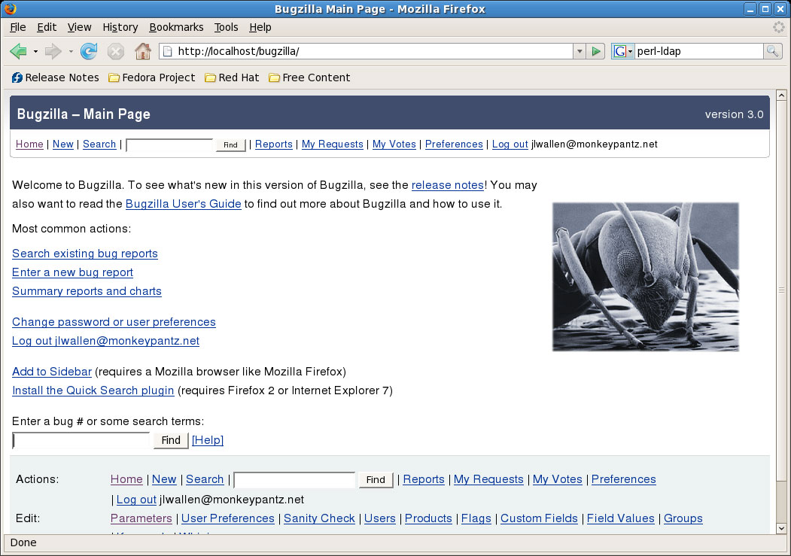.

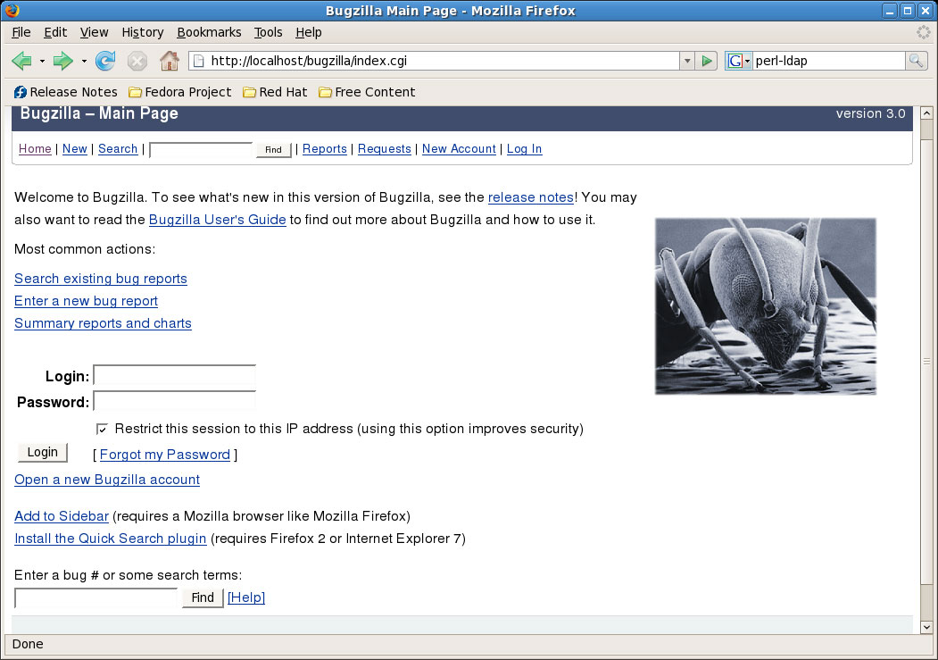

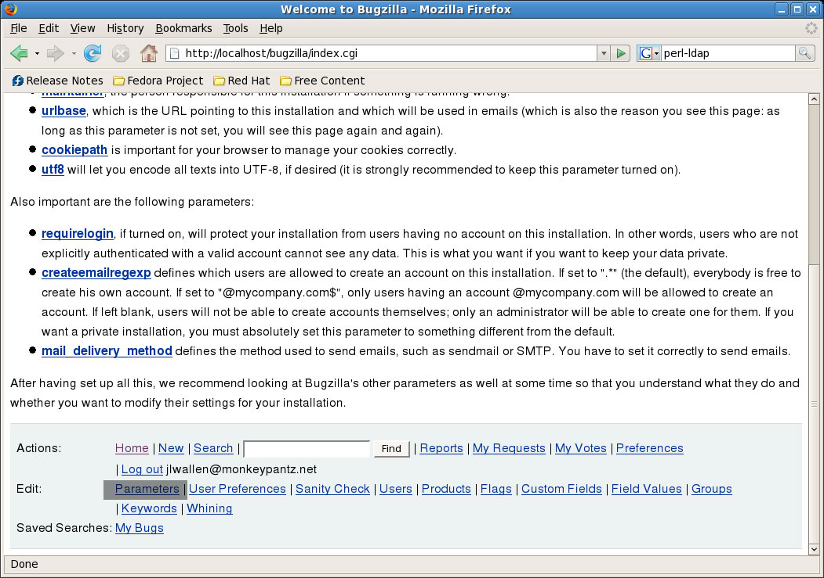

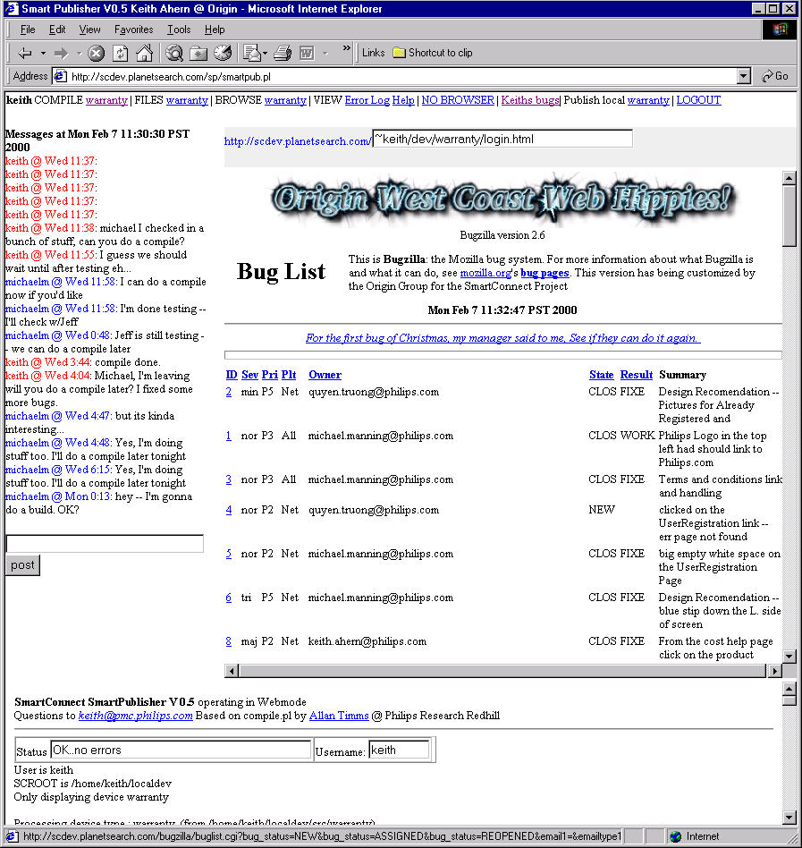

**VIVA QUESTIONS :**

1. What is meant by bug?
2. How to create new bug?
3. What are the activities involved in bugzillium?
4. What are the advantages of the bugzillium testing tool?
5. How can we generate a report?

**Experiment V:**

**Aim: Study of Any Test Management Tool ( Test Director)**

Test Director is a global test management solution which provides communication, organization, documentation and structure to the testing project.

Test Director is used for

* Mapping Requirements to User acceptance test cases
* Test Planning by placing all the test cases and scripts in it.
* Manual testing by defining test steps and procedures
* Test Execution status
* Defect Management

**The Test Director Testing Process**

Test Director offers an organized framework for testing applications before they are deployed. Since test plans evolve with new or modified application requirements, you need a central data repository for organizing and managing the testing process. TestDirector guides through the requirements specification, test planning, test execution, and defect tracking phases of the testing process.The TestDirector testing process includes four phases:

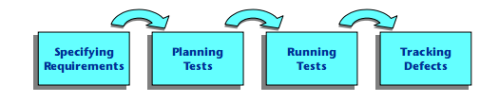

**Specifying Requirements**

* Requirements are linked to tests and defects to provide complete traceability and aid the decision-making process
* See what percent of requirements are covered by tests
* Each requirement in the tree is described in detail, and can include any relevant attachments. The QA tester assigns the requirement a priority level which is taken into consideration when the test team creates the test plan
* Import from Microsoft Word or third party RM tool

**Planning Tests**

The Test Plan Manager enables to divide application according to functionality. Application can be divided into units, or subjects, by creating a test plan tree.

Define subjects according to:

* Application functionality-such as editing, file operations, and reporting
* Type of testing-such as functional, user interface, performance, and load
* As the tests are also linked to defects, this helps ensure compliance with testing requirements throughout the testing process

**Running Tests**

As the application constantly changes, using test lab, run manual and automated tests in the project in order to locate defects and assess quality.

* By creating test sets and choosing which tests to include in each set, test suite can be created? A test set is a group of tests in a Test Director project database designed to achieve specific testing goals.
* Tests can be run manually or scheduled to run automatically based on application dependencies.

**Tracking Defects**

Locating and repairing application defects efficiently is essential to the testing process. Defects can be detected and added during all stages of the testing process. In this phase you perform the following tasks:

* This tool features a sophisticated mechanism for tracking software defects, enabling Testing Team and the project Team to monitor defects closely from initial detection until resolution
* By linking Test Director to e-mail system, defect tracking information can be shared by all Development and Management Teams, Testing and Wipro Software Quality Assurance personnel

**System Requirements for Test Director**

Server System configuration : 128 MB of RAM , 500 MB of free disk space, Win NT server, Win 2K server, IIS 5.0, MS Access/Oracle 7.x,8.x,9/MS SQL Server Client System configuration : 64 MB of RAM , 10 MB of free disk space, Win 95/98/NT/2K/XP, IE 5 , Netscape 4.7

**VIVA QUESTIONS:**

1. What is an error?
2. How many types of testing are there?
3. What is meant by running test?
4. What are the system requirements for test director?
5. What are the tracking defects?

**Experiment VI:**

**Aim: Study of any open source testing tool (Test Link)**

Test link is an open source test management tool. It enables creation and organization of test cases and helps manage into test plan. Allows execution of test cases from test link itself. One can easily track test results dynamically, generate reports, generate test metrics, prioritize test cases and assign unfinished tasks. Its a web based tool with GUI, which provides an ease to develop test cases, organize test cases into test plans, execute these test cases and generate reports. Test link exposes API, written in PHP, can help generate quality assurance dashboards. The functions like AddTestCase ToTestPlan, Assign Requirements, Create Test Case etc. helps create and organize test cases per test plan. Functions like GetTestCasesForTestPlan, GetLastExecutionResult allows one to create quality assurance dashboard.

Test Link enables easily to create and manage Test cases as well as organize them into Test plans. These Test plans allow team members to execute Test cases and track test results dynamically, generate reports, trace software requirements, prioritize and assign tasks. Read more about implemented features and try demo pages.

**Overall structure**

There are three cornerstones: **Product**, **Test Plan** and **User**. All other data are relations or attributes for this base. First, definition of a couple of terms that are used throughout the documentation.

**Products and Test Plans**

*Product*: A Product is something that will exist forever in Test Link. Products will undergo many different versions throughout their lifetimes. Product includes Test Specification with Test Cases and should be sorted via Keywords.

*Test Plan*: Test Plans are created when you‘d like to execute test cases. Test plans can be made up of the test cases of one or many Products. Test Plan includes Builds, Test Case Suite and Test Results.

*User:* An User has a Role, that defines available Test Link features.

**Test Case Categorization** Test Link breaks down the test case structure into three levels Components, Categories, and test cases. These levels are persisted throughout the application. *Component*: Components are the parents of Categories. Each Component can have many Categories. *Category*: Categories are the parents of test cases. Each Category can have many test cases. *Test Case*: Test cases are the fundamental piece of Test Link.

*Test Specification*: All Components, Categories and test cases within Product.

*Test Case Suite*: All Components, Categories and test cases within Test Plan.

**Test Specification**

**Creating Test Cases** Tester must follow this structure: Component, Category and test case. At first you create Component(s) for your Product. Component includes Categories. Category has the similar meaning but is second level of Test Specification and includes just Test Cases.

User can also copy or move Test Cases.

Test Cases has following parts:

• Title: could include either short description or abbreviation (e.g. TL-USER-LOGIN)

• Summary: should be really short; just for overview.

• Steps: describe test scenario (input actions); can also include precondition and cleanup information here.

• Expected results: describe checkpoints and expected behavior a tested Product or system.

**Deleting Test Cases**

Serves for navigation in Test Case Suite via tree menu, filtering and define a tested build.

**Test Status** Execution is the process of assigning a result (pass, fail, blocked) to a test case for a specific build. ‗Blocked‘test case is not possible to test for some reason (e.g. a problem in configuration disallows to run a tested functionality).

**Insert Test results** Test Results screen is shown via click on an appropriate Component, Category or test case in navigation pane. The title shows the current build and owner. The colored bar indicate status of the test case. Yellow box includes test scenario of the test case.

**Updated Test Cases**: If users have the proper rights they can go to the ―Update modified test case‖ page through the link on main page. It is not necessary for users to update test cases if there has been a change (newer version or deleted).

**Advantages:**

1. Easy in tracking test cases (search with keyword, test case id, version etc)

2. We can add our custom fields to test cases.

3. Allocating the work either test case creation/execution any kind of documents is easy

4. When a test cases is updated the previous version also can be tracked

5. We can generate results build wise

6. Test plans are created for builds and work allocations can be done.

7. Report is one of the awesome functionality present in the Test link, it generates reports in desired format like HTML/ CSV /Excel and we can create graphs too.

8. And the above all is done on the privileges based which is an art of the test link and i liked this feature much

**VIVA QUESTIONS:**

1. Define debugging.
2. Write the differences between design patterns and frameworks
3. What is V Testing?
4. Name the two issues for software quality.
5. Define user satisfaction testing.
6. Define test plan.

**Example of Test Link workflow:**

1. Administrator create a Product “Fast Food” and a user Adam with rights “leader” and Bela with rights “Senior tester”.

2. Adam imports Software Requirements and for part of these requirements generates empty Test cases.

3. Bela describe test sneario of these Test cases that are organized according to Components and Categories.

4. Adam creates Keyword: “Regression” and assignes this keyword to ten of these test cases.

5. Adam creates a Test Plan “Fish & Chips”, Build “Fish 0.1” and add Test Cases with keywords “Regression”.

6. Adam and Bela execute and record the testing with result: 5 passed, 1 failed and 4 are blocked.

7. Developers make a new build “Fish 0.2” and Bela tests the failed and blocked test cases only. Exceptionally all these five Test cases passed.

8. Manager would like to see results. Administrator explains him that he can create account himself on the login page. Manager does it. He has “Guest” rights and could see results and Test cases. He can see that everything passed in overal report ;-) and problems in build “Fish 0.1” in a report for particular Build. But he can change nothing.

**8. REFERENCE BOOKS:**

1. Unified Modeling Languages by Grady Bootch.
2. Software Testing Methodologies by William E. Perry
3. Software Testing Techniques by Boris Beizer.
4. The craft of software testing – Brain Marick, pearson education.
5. Software testing ,3rd Edition, P.C.jargensen, Aurbach publications
6. Software testing, N.chauhan, Oxford university press.
7. Introduction to software testing, P.Ammann & J.offutt, Cambridge univ.press
8. Effective methods of software testing,perry,John Wiley,2nd Edition,1999
9. Software testing concepts and tools, P.Nageswara Rao, dreamtech press.
10. Software testing, M.G.Limaye, TMH.